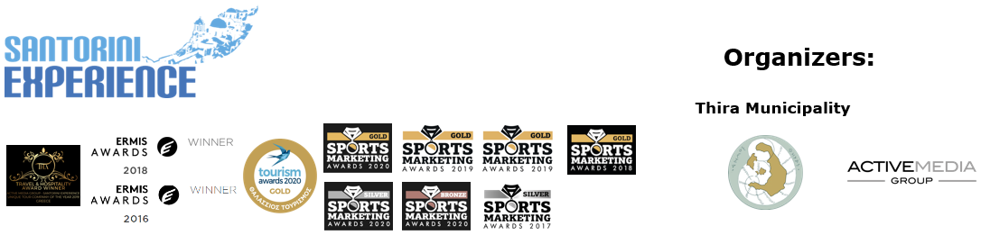

**PRESS RELEASE**

**Santorini Experience Enters a New Era**

**Athens, July 18, 2022** - Santorini is making a dynamic come back to the world of sports tourism this year, the ever-growing alternative form of tourism in Greece, bringing a new era to **Santorini Experience.**

**Thira Municipality** is not limited to simply hosting a major sporting event on the island of **Santorini,** as it intends to highlight the cultural wealth of a globally leading tourism destination, organizing **Santorini Experience** on **September 23-25, 2022,** after two years of pandemic.

The history and culture of Santorini’s volcanic complex sparked the global interest in the 1980s and since then the island’s tourist movement began. People who choose to engage with sports tourism, always combine their participation in a sports event with a desire to find out the particular characteristics of the destination they are visiting, at the same time.

This year, **Thira Municipality,** wishing to highlight the history and cultural wealth of the islands, enriches Santorini Experience for the first time, with a **half marathon,** a very popular running route worldwide.

**“Daedalic Kore of Thira” Half Marathon**

The marble Daedalic Kore of Thira, a unique archaeological finding of supernatural size (**2.30 meters height** and about 750 kilograms weight), dating back to 640 BC. (7th century), was found preserved in excellent condition at the site of Sellada in Ancient Thira, on November 24, 2000, by the late archaeologist Charalampos Sigalas. It highlights the vast history of Santorini and is placed chronologically and aesthetically in the era of the genesis of the monumental Greek sculpture. This remarkable sculpture, which will soon be exhibited to the world for the first time, in the outdoor area of ​​the Archaeological Museum of Thira, which is being currently renovated, gives its name to the **first half-marathon run,** which is held for the first time on the island. The **“Daedalic Kore of Thira” Half Marathon** will take place on **Saturday, September 24, 2022,** running across the enchanting areas of **Oia, Imerovigli and Fira.**

**1.5 miles “L & E Nomikos” Open Water Swimming route from the Volcano to Fira**

In the most beautiful caldera in the world, created by the successive eruptions of Santorini’s volcano, from prehistoric times to 1950, participating athletes will have the opportunity to swim in the **unique 1.5 miles (2.4 km) “L & E Nomikos” open water swimming route,** of **Santorini Experience.** The swimming event is going to be held on **Sunday September 25, 2022,** starting from the volcano with its finish line being at the old port of Fira, under the imposing view of the island. Watch some highlights from the **amazing swimming route** here: [**https://youtu.be/FKyh6_hoL4g**](https://youtu.be/FKyh6_hoL4g)

From this year, the swimming route will bare the name **“L & E Nomikos”** in honor of the founders of the **“Loula & Evangelos Nomikos”** Foundation, established in 1979 by the shipowner Evangelos Nomikos, who adored the sea and his island. The construction of the cable car, which connects the city of Fira with the old port (Bay of Fira), the end point of the swimming route, is a pioneering project of the Foundation, which was completed 40 years ago and was put into operation with a great contribution to the service of the residents and visitors. At the same time the cable car has benefited the entire island over time, since the Foundation’s income is used for great projects and the overall support of the community. It is a debt of honor in the memory of these great benefactors of the Municipality of Thira, to name this unique swimming route after them, from now on.

**Vikos Natural Mineral Water** is the event’s **Official Water.**

**Santorini Experience** takes place this year for the **6th year** and is organized by the **Municipality of Thira** and the Sports Tourism department of **ActiveMedia Group.**

More information on **new surprises of this year's event, the opening of registrations and special offers** for access to Santorini, will be announced in the coming weeks at: [www.santorini-experience.com](http://www.santorini-experience.com)

Sports Production: **ActiveMedia Group**

#SantoriniExperience

**Information for the editors:**

**Press Office Contact:**

Tel.: +30 210 9343020

e-mail: [pr@activemedia.com.gr](mailto:pr@activemedia.com.gr)

<mailto:pr@activemedia.com.gr>

**Website:** [www.santorini-experience.com](http://www.santorini-experience.com/)

**Facebook Page:** <https://www.facebook.com/SantoriniExperience>

**Instagram Page:** <https://www.instagram.com/santoriniexperience/>

**Twitter Account:** <https://twitter.com/Sant_Experience>

**YouTube Channel:** <https://www.youtube.com/channel/UCGconq7q45TYim8qFg71XlA>