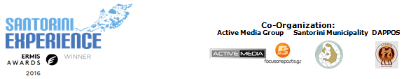

PRESS RELEASE

Athens, May 11, 2017

Registrations for “Santorini Experience” have begun!

Swimming and running are part of the 3-day event…

The biggest sports tourism event for professional and amateur athletes in Greece, the “3rd Santorini Experience”, is ready to welcome anyone who wants to boost their adrenaline rush by taking part in the running and swimming races.

Anyone who wishes to find themselves in magical Santorini between the 6th and 8th of October 2017, will have the opportunity to try out their abilities in open water swimming, which takes place on Saturday October 7th, in a 1.5 mile (2,4km) race from the volcano to the old port of Fira.

For those who prefer running, the schedule includes three different routes, on Sunday October 8th, which have as background the unique images of the volcano, overlooking the Caldera as well as the unique settlements of Imerovigli, Firostefani and Oia. More specifically, the 5 km running and dynamic walking, a 10 km route for long-distance runners and 15 km race for those who love stamina, technique and strength. All routes start at the desalination plant in Oia, with parts of trail track, and again end in Oia.

This year, for the first time there will be time recording for all runners and swimmers. You may register in the link that follows below:
http://activemedia.com.gr/product/santorini-experience-2017/

Greek world champion of open water swimming, Kelly Araouzou, who will be attending, pointed out: “It is with great pleasure that I will be swimming in the beautiful waters of Santorini for the 3rd consecutive year. Santorini Experience is, to me, a unique experience as besides the athletic part that concerns swimming, the feeling of competing in one of the most famous places in the world is incredible! I strongly advise everyone to come and live this unique experience, on an island which is a tourist destination for the entire world all year long!”
Let it be noted that “Santorini Experience” was awarded in this year’s Ermis Awards with the Golden Award for the best sports event production for the previous year!

In the following link you can watch the teaser video of Santorini Experience 2017: https://youtu.be/yw4GCjwv0IQ

More information regarding the activities schedule and the hospitality packages of sponsors will be announced in the following weeks.

Official Sponsors: Blue Star Ferries, Alafouzos Sport, Athina Luxury Suites
Official Supporters: “Vikos” Natural Mineral Water, Avance Rent A Car, Aqua Vista Hotels, Wyndham Grand Athens, Santorini Boatmen Union
Hospitality Sponsors: Aqua Vista Hotels, Athina Luxury Suites, Vedema A Luxury Collection Resort Santorini, West East Suites, White Pearl Villas, Central Fira Hotel, Memories Hotel, Loizos Stylish Residencies, Esperas Santorini, Sienna Residencies, Hotel Rivari Santorini
Official Travel Agent: Smile Acadimos

Under the Auspices of the Greek National Tourism Organization
Under the Auspices of the Hellenic Swimming Federation
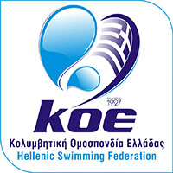

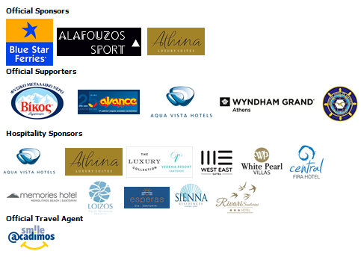
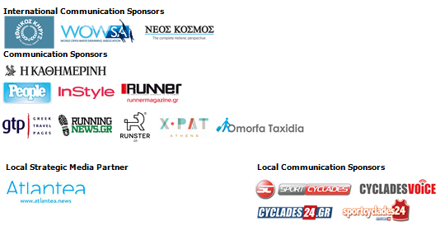

Information for editors:

Press Office Contact:
Tel.: +30 210 9343020, fax: +30 210 9316505
e-mail: pr@activemedia.com.gr

Website: www.santorini-experience.com
Facebook Page: https://www.facebook.com/SantoriniExperience
Twitter Account: https://twitter.com/Sant_Experience
YouTube Channel: https://www.youtube.com/channel/UCGconq7q45TYim8qFg71XlA
Instagram Page: https://www.instagram.com/santoriniexperience/
Hashtag: #SantoriniExperience

