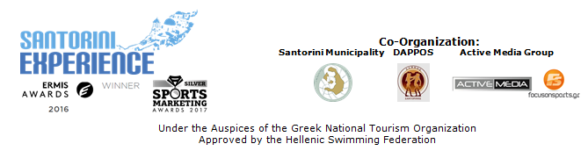

PRESS RELEASE

“Santorini Experience” with great names in open water swimming!

Early bird offer valid until May 30th

Athens, May 25, 2018. Registrations at “Santorini Experience” are proceeding intensively, even though we are 5 months away from the event, while special offers and discounts continue for those who choose to travel to the enchanting island of the Cyclades on October 5-7, 2018.

As far as the race is concerned, we must highlight that any event involving an open water swimming race should take place with the approval of the Hellenic Swimming Federation, in accordance with FINA’s safety rules; as is always the case with “Santorini Experience”. For one more year, the open water swimming race will be implemented with the support of Santorini Boatmen Union and the assistance of Lifeguard Patrol that will take care of the safety of all participants.
For the 2nd consecutive year the great Hungarian swimmer, Attila Manyoki will swim again in the waters of Santorini. The 45-year-old recognized athlete in open water swimming with several successes and a member of the International Marathon Swimming Hall of Fame (IMSHOF), has completed hundreds of open water swimming marathons and has swum twice the 90km distance. Manyoki stated for his participation: “I am coming back at "Santorini Experience" following my participation last year. My experience was amazing. I also felt lucky myself over there. Unique place, the sea is beautiful with the deep blue colour. The organization was fantastic. They do the best for the people. You don't need to think about anything just enjoy your time on the weekend! I am really waiting for October to enjoy again this fantastic place! In Santorini you could find everything, excellent hotels, restaurants, foods, friendships and the perfect view to the volcano! I wish much more people to come to this event and spend a perfect weekend on the island and enjoy the sea and many fantastic sportmans! I will be there! Let's jump together to the sea! The sea is open!”.

As far as the swimming route is concerned, it is designed by the federal technical coach, with distinctions in the open water swimming races, in the Olympic Games and World Championships, Nikos Gemelos. Mr. Gemelos highlighted: “The 4th “Santorini Experience” is a fact. It is with great pleasure to welcome great names of Greek athletes, as well as to see the interest of foreign athletes with great performances. We have designed and organized age groups, depending on the final number of participants. At the same time, we will have a separate category for those who choose to wear a full-body swimming suit (wetsuit category). Our goal is to satisfy every participant and our perspective is that every year we learn from our contestants according to their requirements and we adapt to their needs so that “Santorini Experience” does not remain in the memories of those taking part as a swimming race, but as a lifetime experience”.
Take part in the successful sports tourism event in Greece by taking advantage of the early bird prices which are valid until May 31st. If participants register until the end of the month, the cost for early bird registrations amounts to 20€ per activity. Those who decide to travel to Santorini to compete will have to move quickly to take advantage of the offer as from 1/6/2018 the registration price will be set at 30€ per activity. Registrations will end on August 31, 2018. Register now at the following link: https://activemedia.travelotopos.com

Along with early bird completion, Avance Rent A Car provides a very tempting offer, which gives the opportunity to participants in the 4th “Santorini Experience” to make their reservation, for any vehicle of their choice regarding their travel to the island with a 30% discount on the official list until June 30th. Whereas from July 1st and until the event, reservations will have a 15% discount.
In terms of bookings, participants may either send an email to sales@avance.gr or call +30 2109011300.

In the following link you may watch the video teaser of Santorini Experience 2018: https://youtu.be/kZmMBZDXMSc

Ryanair is the official airline partner of the event for a third year in a row. Once again, official sponsors of the event are Ford Motor Hellas, Alafouzos Sport and Athina Luxury Suites. Official supporters are Natural Mineral Water “Vikos”, Avance, Santorini Hoteliers Association, Meltemi Hotels & Resorts, Aqua Vista Hotels and Boatmen Union Santorini.

“Santorini Experience” is a co-organization of Municipality of Santorini, DAPPOS and Active Media Group. More info in www.santorini-experience.com

Official Airline Partner: Ryanair
Official Sponsors: Ford Motor Hellas, Alafouzos Sport, Athina Luxury Suites
Official Supporters: Natural Mineral Water “Vikos”, Avance Rent A Car, Santorini Hoteliers Association, Meltemi Hotels & Resorts, Aqua Vista Hotels, Boatmen Union Santorini
Assisted by: Lifeguard Patrol, Assyrtico Wine Restaurant Café
Strategic Partner: National Geographic

Official Hashtag: #SantoriniExperience

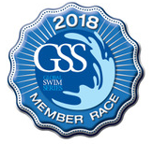
Under the Auspices of the Greek National Tourism Organization
Approved by the Hellenic Swimming Federation
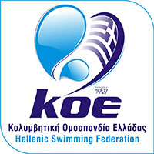

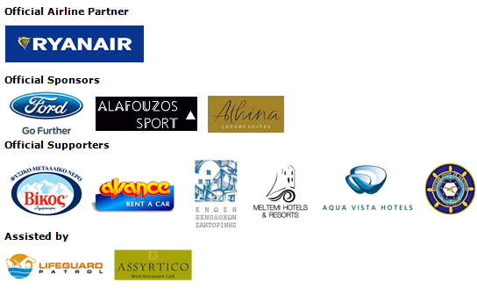


Information for the editors:

Press Office Contact:
Tel.: +30 210 9343020, fax: +30 210 9316505
e-mail: pr@activemedia.com.gr

Website: www.santorini-experience.com
Facebook Page: https://www.facebook.com/SantoriniExperience
Twitter Account: https://twitter.com/Sant_Experience
YouTube Channel: https://www.youtube.com/channel/UCGconq7q45TYim8qFg71XlA
Instagram Page: https://www.instagram.com/santoriniexperience/

