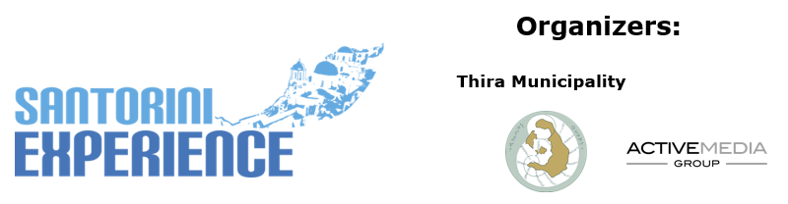

PRESS RELEASE

The Ultimate Sports Event of Santorini Experience
Coming to Santorini on October 3-6

Running on the Caldera with a View of the Volcano

Santorini, July 5, 2024 – The unparalleled natural beauty of Santorini, the enchanting sunset, the volcano with the impressive Caldera and the breathtaking view of the Aegean, together with the island’s unique Cycladic architecture create an explosive setting for a distinctive sports and tourism experience. The exquisite sports tourism event Santorini Experience returns for the 7th year from October 3 to 6, 2024, attracting professional and amateur athletes from all around the world, back to the island.

Running enthusiasts will have the opportunity to enjoy three stunning trail running routes on the Caldera, on the path that connects Oia with Fira, with the magical view of the volcano beside them. The 5km route “Aristides Alafouzos” powered by Miele is for those less initiated in running and those who love dynamic walking. The 10km route powered by SIXT, member of the MOTODYNAMICS GROUP, is for more experienced distance runners, and the 15km route powered by HOKA is for those who love strength and endurance. All routes start at the desalination plant in Oia, featuring sections of dirt paths and finish back in Oia.

Watch a video with some breathtaking images from the running routes here: https://youtu.be/6Ivv_lt20UM?si=k5Vx7AhUBzCYGgDa

Great Gifts for Participants
Each participant will receive his/her participation package, which will include: a bag, a technical T-shirt, a medal (for finishers), a timing chip, a swim cap (for the swimming race), a race number (for running), a waterproof race number (for swimming), personal item storage services, refreshments at the start/finish and along the running route, refreshments at the finish of the swimming race, medical coverage with the presence of rescue teams for the running races, lifeguards for the swimming race, and special gifts from sponsors.
Register here: https://www.more.com/sports/santorini-experience-en/

The schedule also includes the traditional open water swimming event. Specifically, participants will swim from the Volcano and finish at the old port of Fira, facing the imposing view of the island, in the 1.5-miles (2.4 km) race.

Free Participation for Thira Municipality Citizens
The citizens of Thira Municipality can participate for free. Thira residents can register for free from Monday, July 8, exclusively at Alafouzos Sport, the event’s Official Sports Store.

Travel to Santorini with a 30% Discount on Ferry Tickets
Those visiting Santorini by ferry for Santorini Experience can travel with the safety and comfort of Blue Star Ferries, the event’s Official Sponsor. The top Greek shipping company offers a 30% discount on ferry tickets (all seats except cabins) from Piraeus, Cyclades, and Dodecanese to Santorini on round-trip tickets and 30% on vehicles for those visiting the event and the island from October 1 to 8, 2024. Each person who has completed their registration is entitled to the same discount for 3 additional people (if they are their escorts).

Premium Mobility Partner of the event is SIXT, a member of the MOTODYNAMICS Group.
GoPro is the event’s Official Action Camera.
Miele, and Athina Luxury Suites are the event’s Bronze Sponsors.

Blue Star Ferries is the Official Sponsor.
HOKA is the Official Footwear Sponsor.
Vikos Natural Mineral Water is the Official Water.
Alafouzos Sport is the event’s Official Sports Store.
Luanvi is the Official Technical T-shirt.
Kois Optics are the Official Optics Partner.
PHEE, Messinian Spa, Santorini’s Best Driver, and Nobu Hotel Santorini are the event’s Partners.
π³= Plastic Pollution Prevention is the Sustainability Partner.

The event will be implemented with the invaluable support of our Hospitality Sponsors, who promote the island with special prices and offer enormous support to the event. The confirmed hotels so far are the following: Athina Luxury Suites, Nobu Hotel Santorini, NOUS Santorini, Katikies Garden Santorini Vedema, A Luxury Collection Resort Santorini (Empiria Group), Santo Pure Oia Suites & Villas, Santo Mine Oia Suites, Apeiron Blue, 270 Oia’s View, West East Suites, Lydia’s House, Nikki Beach Resort & Spa Santorini, The Majestic Hotel Santorini (Kord Hotels), Coco-Mat Hotel Santorini, Blue Dolphins, De Sol Hotel & Spa, Neoklassiko Koukouli, Noni Studios, Santoriviera House, Ifestau4, En Plo Boutique Suites, Epavlis Grace, Fanouris Condo, MONOLiTHIA, Epavlis Hotel (Meraki Collection), K & K Unique Holiday Homes, Loizos Stylish Residences, Venus Sunrise Suites & Villas, Sienna Eco Resort.

Check here the available special offers from the hospitality sponsors for the participants of Santorini Experience, which are only valid, during the event’s days: https://www.santorini-experience.com/en/event-info/accommodation-offers/

Santorini Experience is organized by the Municipality of Thira and ActiveMedia Group. The event is held under the auspices of the Greek Ministry of Tourism and the Greek National Tourism Organization.
For more information visit: www.santorini-experience.com

#SantoriniExperience

Website: www.santorini-experience.com
Facebook Page: https://www.facebook.com/SantoriniExperience
Instagram Page: https://www.instagram.com/santoriniexperience/
Twitter Account: https://twitter.com/Sant_Experience
YouTube Channel: https://www.youtube.com/channel/UCGconq7q45TYim8qFg71XlA
TikTok Account: https://www.tiktok.com/@santorini_experience

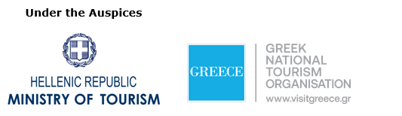

Press Office Contact:
Phone: +30 210 9343020
Email: pr@activemedia.gr

