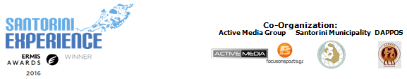

PRESS RELEASE

Athens, May 31, 2017

Global Promotion of the “Santorini Experience”!

The 5 km route is renamed in honor of Aristides Alafouzos

Athens, May 31, 2017. In a “warm” event in the center of Athens, the official presentation of the 3rd “Santorini Experience,” which will take place on the enchanting island of Santorini from October 6 to 8, was held yesterday. Hosted at the Wyndham Grand Athens hotel, the press conference of the top sports tourism event for professional and amateur athletes in Greece was attended by journalists and many distinguished guests. The event featured an exclusive screening of the show with the best moments of the “Santorini Experience 2016,” prior to its broadcast on FOX Sports.
Many honored guests attended the event, closely associated with the successful three-day sports event in Santorini, which will be held for the third consecutive year. Among the attendees were the Mayor of Thira, Mr. Nikos Zorzos, the President of the Hellenic Swimming Federation, Mr. Dimitris Diathesopoulos, the President of DAPPOS, Mr. Lefteris Tzouros, the swimming technical directors Nikos Gemelos and running director Nikos Polias, the head of the Kids' Athletics program of the event, Periklis Iakovakis, as well as the National Open Water Swimming Team of Greece, who were some of the key figures of the press conference.
The Mayor of Thira, Mr. Nikos Zorzos, made a very important announcement, stating, among other things: “We are particularly pleased to welcome the 3rd consecutive Santorini Experience! The sporting event has now become a tradition for our island, with more and more visitors planning their holidays around it. This year, which is especially emotionally charged for us, the 5 km route will be named ‘Aristides Alafouzos,’ beginning at the desalination plant in Oia, which he donated to the island’s residents. This act, as a minimal tribute to the late Aristides Alafouzos, will be the starting point for other actions to express our gratitude.”
The President of the Hellenic Swimming Federation, Mr. Dimitris Diathesopoulos, then took the floor, stating: “The event is part of sports tourism, which our country so desperately needs, and combined with its location, the beautiful Santorini, provides the motivation for a significant event that transcends Greece’s borders and has now become an international sports and tourism event. The Hellenic Swimming Federation, by placing it under its auspices and with the participation of the National Team and top athletes in OPEN WATER, actively supports the event, contributing to its international recognition and establishment.”
The Secretary-General of the Greek National Tourism Organization, Mr. Dimitris Tryfonopoulos, also addressed the audience: “Last year, athletes from 28 countries discovered why this island offers unique experiences to its visitors. This year, those who participate will experience it firsthand. This event aligns with the goals of the GNTO to internationally promote Greece’s destinations, as well as alternative forms of the country’s tourism product, ensuring sustainable development year-round. Moreover, through media coverage, such as that of FOX Sports, one of the world’s largest sports networks, we have the opportunity to spread our message to countless potential visitors, far exceeding the 28 million we welcomed to the country in 2016.”
It should be noted that the premiere of the show featuring the best moments of last year’s FOX Sports event in Greece will air via NOVA on June 19.
The President of the Municipal Sports Cultural Environmental Organization of Santorini (D.A.P.P.O.S.), Mr. Lefteris Tzouros, added: “Santorini Experience, taking place from October 6 to 8, comes full of energy and new ideas. Its establishment as a tradition is now a fact, which makes us particularly happy, as in a relatively short period it has gained the global prestige that was our initial goal. The successful collaboration between the Municipality of Thira - DAPPOS - ACTIVE MEDIA, the support of the Hellenic Swimming Federation and the GNTO, as well as our sponsors, are the factors that have given global momentum to the event. We invite everyone to experience the challenge of the Santorini Experience firsthand.”

A significant part of the event's success is also due to Ryanair, as the official airline of the “Santorini Experience,” offering the opportunity to connect Athens with Santorini via direct flights from 13 international cities. Additionally, for those choosing a flight with a stopover in Athens, the collaboration with Wyndham Grand Athens offers accommodation with particularly attractive packages, something happening for the first time in a sports event held outside Athens.

The "Santorini Experience" is the 1st sports tourism event in Greece with a special section on its website for the partner hotels, aiming to attract more athletes, aiming to boost tourism with greater attendance from abroad. It is characteristic that in almost a month that the registrations are active, 80% of them come from Russia, Austria, Italy and Germany.

The event innovates by once again taking care of amateur athletes with the addition of the safety life jacket, of high standards and quality, which gives another incentive to the participant to choose the Santorini Experience.

All of the above would not have come to fruition if from day one the idea of the "Santorini Experience" had not been supported by its sponsors. "Vikos" is one of these companies, which for the 3rd consecutive year will give the opportunity to athletes who will take part this year, to quench their thirst with the natural mineral water "Vikos" that contributes to the good functioning of the body.

In the following link you can directly register your participation http://activemedia.com.gr/product/santorini-experience-2017/
The "Santorini Experience" will be held under the auspices of the Greek National Tourism Organisation and the Greek Swimming Federation (K.O.E.), co-organised by the Municipality of Thera, D.A.P.P.O.S. and the Active Media Group.

In the following link you can watch the teaser video of Santorini Experience 2017: https://youtu.be/yw4GCjwv0IQ

More information regarding the activities schedule and the hospitality packages of sponsors will be announced in the following weeks.

Official Hashtag: #SantoriniExperience

Official Airline Partner: Ryanair
Official Sponsors: Blue Star Ferries, Alafouzos Sport, Athina Luxury Suites
Official Supporters: “Vikos” Natural Mineral Water, Avance Rent A Car, Aqua Vista Hotels, Wyndham Grand Athens, Santorini Boatmen Union
Hospitality Sponsors: Aqua Vista Hotels, Athina Luxury Suites, Vedema A Luxury Collection Resort Santorini, West East Suites, White Pearl Villas, Central Fira Hotel, Memories Hotel, Loizos Stylish Residencies, Esperas Santorini, Sienna Residencies, Hotel Rivari Santorini
Official Travel Agent: Smile Acadimos

Under the Auspices of the Greek National Tourism Organization
Under the Auspices of the Hellenic Swimming Federation
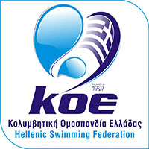

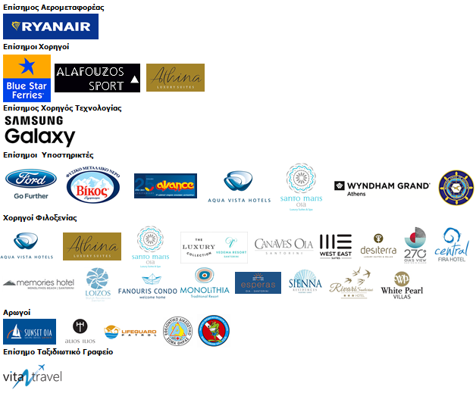
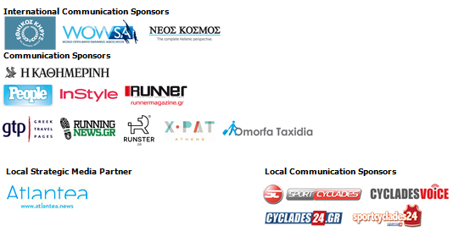

Information for editors:

Press Office Contact:
Tel.: +30 210 9343020, fax: +30 210 9316505
e-mail: pr@activemedia.com.gr

Website: www.santorini-experience.com
Facebook Page: https://www.facebook.com/SantoriniExperience
Twitter Account: https://twitter.com/Sant_Experience
YouTube Channel: https://www.youtube.com/channel/UCGconq7q45TYim8qFg71XlA
Instagram Page: https://www.instagram.com/santoriniexperience/
Hashtag: #SantoriniExperience

