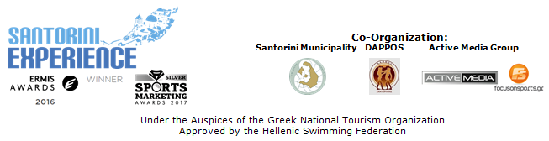

PRESS RELEASE

Hospitality sponsors embrace “Santorini Experience”

Tempting offers and special accommodation packages

Athens, June 21 2018. Summer has arrived, and as we approach the holidays, we also move into the rhythms of “Santorini Experience”, and participants need to book their stay in the breathtaking island of the Cyclades, for October 5-7, 2018, taking advantage of the discounts offered by the hospitality sponsors that apply to this specific period for the event.

Registration and special offers continue with an undiminished pace, with the local community offering its very best, as hospitality sponsors are loyal to their “appointment” this year, offering dynamic support to the island and special accommodation prices to those participating in Santorini Experience. Hospitality Sponsors are: Santorini Hoteliers Association, Meltemi Hotels & Resorts, Aqua Vista Hotels, Athina Luxury Suites, Santo Maris Oia Luxury Suites & Spa, West East Suites, Desiterra Luxury Suites & Villas, 270 Oia’s View, Central Fira Hotel, Fanouris Condo, Monolithia, Casa Iphigenia, Sienna Resort. Registrations will close on August 31, 2018. Register now in the following link: https://activemedia.travelotopos.com

For those choosing to travel to the island by plane, Ryanair, the official airline partner of the event for the 3rd consecutive year, will connect Santorini with safety and comfort in privileged fares that will be announced soon.

At the same time, all those wishing to travel to the island by ferry, will be able to enjoy once again this year the safety and comfort of Blue Star Ferries. The top Greek shipping company offers 50% discount on the ferry tickets and vehicles to all those visiting the event and the island from October 1st to 12th 2018. Each person who has completed his/her registration is entitled to the same discount for 3 more people (if these are his/her escorts) or for 4 people (if these are family members).

VitaNTravel, as the official travel agent of the event, will take care and assist all athletes and escorts with information about the ferry routes, ferry tickets, car rentals and accommodation in the island while a special accommodation package has been prepared for the period October 5-7, 2018. You may book this special package for a two-night stay that includes your hotel accommodation, ferry tickets with Blue Star Ferries, in economy class for the itineraries: Piraeus - Santorini (5/10), departure: 07.25 am, arrival: 14.55 pm and from Santorini - Piraeus (7/10), departure: 15.30 pm, arrival: 23.25 pm as well as extra transfers from the hotel to the event venues. The privileged package starts from 130€/person. For more information visit: http://vitantravel.gr/ or call +30 2103249070.

In addition, for the 4th consecutive year Ford Motor Hellas will strengthen Santorini Experience with its presence, with the safety and efficient engines of its cars, as the official sponsor of the event.

For the first time in Santorini Experience, Hellenic Recovery Recycling Corporation (Herrco) will assist the event. In cooperation with the Municipality of Santorini, they aim at a better environmental control of the event and the promotion of recycling in the island.

“Vikos” continues on the side of Santorini Experience for the 4th consecutive year, as an official supporter offering athletes who will take part, the opportunity to quench their thirst with the natural mineral water “Vikos” which contributes to the better functioning of the body.

As far as the open water swimming race is concerned, we must highlight that any event involving an open water swimming race should take place with the approval of the Hellenic Swimming Federation, in accordance with FINA’s safety rules; as is always the case with “Santorini Experience”.

In the following link you may watch the video teaser of Santorini Experience 2018: https://youtu.be/kZmMBZDXMSc

In addition, official sponsors of the event are once again Alafouzos Sport and Athina Luxury Suites. Official supporters are Avance, Santorini Hoteliers Association, Meltemi Hotels & Resorts, Aqua Vista Hotels, Santo Maris Oia Luxury Suites & Spa and Boatmen Union Santorini. National Geographic is for one more year a Strategic Partner of the event.

“Santorini Experience” is a co-organization of Municipality of Santorini, Municipal Sports Cultural Environmental Organization of Santorini (DAPPOS) and Active Media Group. The event is held for one more year under the auspices of the Greek National Tourism Organization. More info at: www.santorini-experience.com

Official Airline Partner: Ryanair
Official Sponsors: Ford Motor Hellas, Blue Star Ferries, Alafouzos Sport, Athina Luxury Suites
Official Supporters: Natural Mineral Water “Vikos”, Avance Rent A Car, Santorini Hoteliers Association, Meltemi Hotels & Resorts, Aqua Vista Hotels, Santo Maris Oia Luxury Suites & Spa, Boatmen Union Santorini
Assisted by: Lifeguard Patrol, Assyrtico Wine Restaurant Café, Hellenic Recovery Recycling Corporation
Official travel agent: VitaNTravel
Strategic Partner: National Geographic

Official Hashtag: #SantoriniExperience
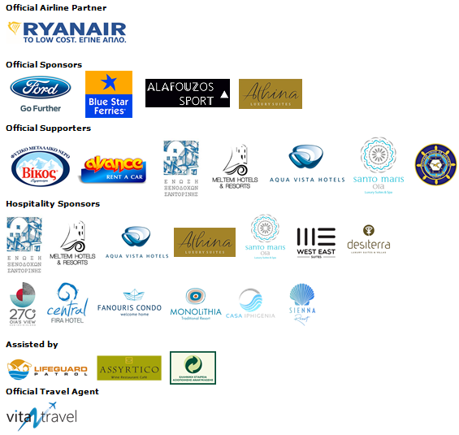
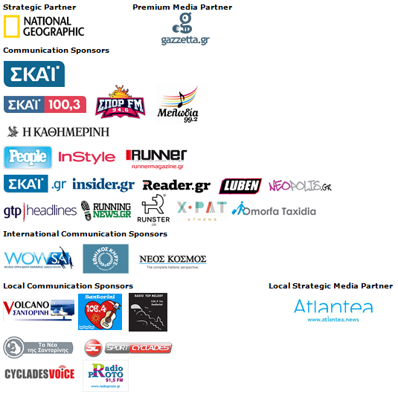
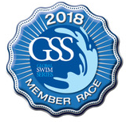
Under the Auspices of the Greek National Tourism Organization
Approved by the Hellenic Swimming Federation
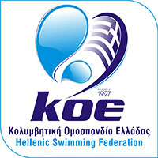

Information for the editors:

Press Office Contact:
Tel.: +30 210 9343020, fax: +30 210 9316505
e-mail: pr@activemedia.com.gr

Website: www.santorini-experience.com
Facebook Page: https://www.facebook.com/SantoriniExperience
Twitter Account: https://twitter.com/Sant_Experience
YouTube Channel: https://www.youtube.com/channel/UCGconq7q45TYim8qFg71XlA
Instagram Page: https://www.instagram.com/santoriniexperience/

