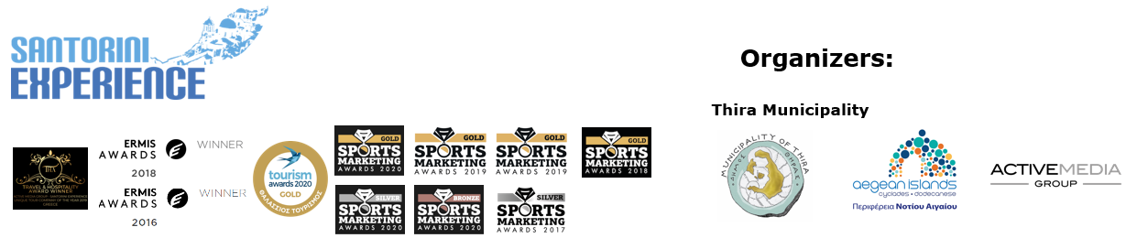

**PRESS RELEASE**

**Santorini Experience 2022**

**Impressive running routes**

**World class names of open water swimming in Santorini**

**Athens, August 31, 2022 –**The great event **Santorini Experience 2022**, which highlights the island’s special alternative forms of tourism such as **cultural, sports and sea tourism,** returns dynamically after two years of the pandemic, featuring new impressive running routes to accompany the established and unique open water swimming route. Amateur and professional swimmers and runners from around the world will visit Santorini, one of the world’s top tourist destinations, on **September 23-25, 2022.**

**Run in the “Daedalic Kore of Thira” Half Marathon**

The **“Daedalic Kore of Thira” Half Marathon** will take place on **Saturday, September 24, 2022** in the morning starting from **Oia,** passing through the enchanting areas of **Imerovigli** and **Fira** and finish back to Oia. This route received the name “Daedalic Kore of Thira”, after the unique archaeological finding (a marble statue of supernatural size, 2.30 meters height and about 750 kilograms weight), dating back to 640 BC. which will soon be exhibited to the world for the first time, 22 whole years after its discovery in the cemetery of Ancient Thira. The event will be honored with the participation of one of the top names in Greek athletics, the Olympian and European champion in the 400m. with hurdles **Periklis Iakovakis** and the Greek-American ultramarathon **Konstantine Dean Karnazes** who will promote and spread the message of Santorini’s sports and cultural tradition with his participation, in the United States of America and around the world.

**Run the 5km “Aristides Alafouzos”**

**Thira Municipality** continues to highlight the cultural wealth of Santorini, through this year’s event activities. The new addition to this year’s schedule concerns the running event and specifically the **5km route** that will be held in the afternoon of **Friday, September** **23,** at **Akrotiri** in Santorini, where one of the most important prehistoric settlements in Europe is located, which has been partially excavated and has revealed great cultural specimens. Starting from the church of **Saint Raphael,** runners will head towards the **Akrotiri Lighthouse,** one of the oldest lighthouses in Greece built in 1892 and reach the westernmost point of the island, returning to Saint Raphael for their finish.

**Rouwendaal, Carlin, Araouzou join Santorini**

Women are in the spotlight as the event will be honored with the presence of the Dutch gold and silver Olympic medalist, world champion and 8-time European champion in open water swimming **Sharon van Rouwendaal,** the British, two-time silver Olympic medalist in open water swimming **Jazz Carlin** and the Greek world champion in open water swimming and athletes’ representative in the Hellenic Swimming Federation’s Board of Directors, **Kelly Araouzou.**

**Participate in the 1.5 miles “L & E Nomikos” Open Water Swimming route from the Volcano**

Athletes will swim in the **unique 1.5 miles (2.4 km) “L & E Nomikos” open water swimming route,** of **Santorini Experience** that will be held in the morning of **Sunday September 25, 2022,** from the volcano to the old port of Fira, under the auspices of the **Hellenic Swimming Federation.** The route has been designed by the race’s technical director with Olympic and world championship swimming distinctions, **Nikos Gemelos.**

Find out about the **routes** and their **technical characteristics** here: [**https://bit.ly/3R84gfq**](https://bit.ly/3R84gfq)

**Register now – Free registration for Thira Municipality Citizens**

Participants can register and take part in the impressive **“Daedalic Kore of Thira” Half Marathon,** the **5km “Aristides Alafouzos”** and the **1.5 miles “L & E Nomikos”** **Open Water Swimming.** The **citizens of Thira Municipality** can participate **for free.** **Register here:** [**https://bit.ly/3oyKX27**](https://bit.ly/3oyKX27)

For **group registrations of 10 people or more, a 20% discount applies.** For more information, please contact the event organizers.

**Metaxa Hospitality Group - Santo Maris** is the event’s **Official Sponsor.**

**Vikos Natural Mineral Water** is the event’s **Official Water.**

**Luanvi** is the **Official Sports Supplier.**

**Englobia** is the **Official Travel Partner.**

**Esperisma bar restaurant** is the **Official Supporter.**

**Book your package in Santorini with a 10% discount**

**Englobia,** as the event’s **Official Travel Partner,** takes care of the participants’ best possible service and their accommodation in Santorini during the event. Those interested can directly book their package for Santorini Experience, which includes accommodation and car rental. Check here for more information about the **packages:** <https://www.englobia.com/vacation-packages/santorini-experience-travel-package>. Take advantage of the **10% discount** offered by Englobia on its packages, using the **discount coupon** at the following link: <https://www.englobia.com/santorini-experience-2022>

The event is **assisted by**: **Santorini Boatmen’s Association, Lifeguard Patrol** and **Voluntary Lifeguards of Santorini.**

Up to this point, this year’s event is enormously supported by the following **hospitality sponsors / hotels: Canaves Oia,** **Kivotos Santorini, West East Suites, Santo Maris Oia Luxury Suites & Spa,  The Tsitouras Collection, Sienna Eco Resort, 270 Oia’s View Lydia’s House Santorini, Vedema - A Luxury Collection Resort Santorini, Sienna Hotel, De Sol Hotel & Spa, Loizos Stylish Residences, K & K Unique Holiday Homes, Andronis Colombo’s Beachfront Hotel, Marvarit Suites, Fanouris Condo, Santo Houses, Athina Luxury Suites.**

Check their**special offers**here:[**https://bit.ly/3AwF0Is**](https://bit.ly/3AwF0Is)

Watch the event’s **teaser video** which includes music of the ancient musical instrument, **santouri** that is an integral part of the Greek tradition and is well-recognized all over the world, here: [**https://youtu.be/NUaOiwE548E**](https://youtu.be/NUaOiwE548E)

**Santorini Experience** takes place this year for the **6th year** and is organized by the **Municipality of Thira,** the **Region of South Aegean** and the Sports Tourism department of **ActiveMedia Group.**

The event will be held **under the auspices** of the **Ministry of Tourism,** the **General Secretariat of Sports of the Ministry of Culture and Sports,** the **Greek National Tourism Organization** and the **Hellenic Swimming Federation.**

Sports Production: **ActiveMedia Group**

More information: [www.santorini-experience.com](http://www.santorini-experience.com/)

#SantoriniExperience

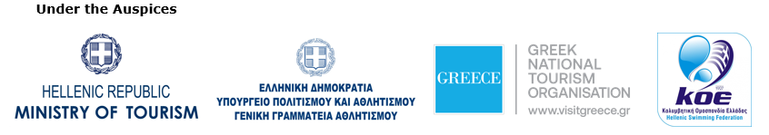

**Information for the editors:**

**Press Office Contact:**

Tel.: +30 210 9343020

e-mail: [pr@activemedia.gr](mailto:pr@activemedia.gr)

**Website:** [www.santorini-experience.com](http://www.santorini-experience.com/)

**Facebook Page:** <https://www.facebook.com/SantoriniExperience>

**Instagram Page:** <https://www.instagram.com/santoriniexperience/>

**Twitter Account:** <https://twitter.com/Sant_Experience>

**YouTube Channel:** <https://www.youtube.com/channel/UCGconq7q45TYim8qFg71XlA>