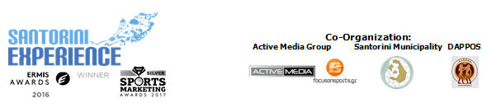

Under the Auspices of the Greek National Tourism Organization
& the Hellenic Swimming Federation

PRESS RELEASE

Great offers & facilitating access to Santorini!

Another award for the successful “Santorini Experience”

Athens, July 19 2017. The 3rd “Santorini Experience” will take place in the breathtaking Santorini from October 6th to 8th. The top sports tourism event for professional and amateur swimmers and runners in Greece, which recently won the silver award at the Sports Marketing Awards 2017 in the “Sports Events / Branded Events” section of the “Sports Tourism” category, offers the opportunity to those wishing to travel to the beautiful Santorini to “measure” their stamina and to “flirt” with the adrenaline!

The official airline partner of “Santorini Experience” Ryanair, which was awarded as the fastest growing company among the top 10 companies with the highest passenger traffic in Athens in 2016, is reinforcing the sports tourism of Santorini and the island’s completeness during the days of the event. The airline company will serve the route Athens-Santorini with fares starting from 14.99€ for bookings which will be completed until Sunday 23/07 and for travels within October. Since these amazing low prices will be available from Wednesday July 19, 2017 and will be snapped up quickly, customers interested in joining the event as active participants should log onto www.ryanair.com or the mobile application of Ryanair and avoid missing out.
You may see Ryanair’s video from “Santorini Experience” at the following link:
https://youtu.be/vtkPKOffvf4

At the same time, all those wishing to travel to the island by ferry, will be able to enjoy once again this year the safety and comfort of Blue Star Ferries. The top Greek shipping company offers 50% discount on the ferry tickets and vehicles to all those visiting the event and the island from October 2nd to 13th 2017. Each person who has completed his/her registration is entitled to the same discount for 3 more people (if these are his/her escorts) or for 4 people (if these are family members).

For the third consecutive year, ambassadors and organizers will move with the safety and efficient engines of the cars of Ford Motor Hellas, the official supporter of “Santorini Experience”.

“Santorini Experience” will receive for one more year the support of Avance Rent A Car. As an official car rental company of the event Avance Rent A Car will cover the event and all visitors’ car rental needs with one of the fastest growing car rental networks with presence in Greece & Cyprus and all major airports and will offer a 15% discount on car rentals.

VitaNTravel, as the official travel agent of the event, will take care and assist all athletes and escorts with information about the ferry routes, ferry tickets, car rentals and accommodation in the island. For more information visit: http://vitantravel.gr/home/

“Santorini Experience” is a world-renowned event with global broadcast, and it is worth noting that the show with the best moments of the event from 2016, which was screened in Greece via FOX Sports will also be broadcasted in 13 Asian countries (Hong Kong, Cambodia, Indonesia, Philippines, Singapore, Thailand, Vietnam, Macau, Mongolia, Myanmar, Papua New Guinea, Malaysia and Brunei) on ​​July 26th (18.30 Hong Kong time zone) and July 31st (13.30 Hong Kong time zone).

Regarding the athletic part of the event, and while registrations have already surpassed the record number of last year during the first 60 days, the schedule includes a 1.5-mile open water swimming race, on Saturday 7 October 2017 and running routes of 15km, 10km & 5km, on Sunday 8 October 2017.

The swimming and running registrations continue with an undiminished pace at the official page of the event: http://activemedia.com.gr/product/santorini-experience-2017/ or alternatively at the store of the official sponsor Alafouzos Sport in Fira, which supports the event for a 3rd year.

The support from Santorini entrepreneurs does not stop there, as Aqua Vista Hotels will support for a second consecutive year both as an official supporter and hospitality sponsor the event, providing high quality hosting services to the participants and visitors of the island.
Similarly, Santo Maris Oia Luxury Suites & Spa promises an unforgettable holiday experience to the visitor, at an environment that is tailored to modern needs, offering to the event and thus recognizing the great significance of “Santorini Experience” for the island and its tourism.
At the same time, Canaves Oia is listed in the hospitality sponsors, while Sunset Oia Sailing Cruises, as the expert of organized sailing tours in Santorini will assist the event.
The hospitality sponsors supporting the event are: Aqua Vista Hotels, Athina Luxury Suites, Santo Maris Oia Luxury Suites & Spa, Vedema A Luxury Collection Resort Santorini, Canaves Oia, West East Suites, 270 Oia's View, Central Fira Hotel, Memories Hotel, Loizos Stylish Residencies, Fanouris Condo, Monolithia Hotel, Esperas Santorini, Sienna Residencies, Hotel Rivari Santorini, White Pearl Villas.

"Santorini Experience" will take place under the auspices of the Greek National Tourism Organization and the Hellenic Swimming Federation with the co-organization of the Municipality of Santorini, DAPPOS and Active Media Group.

More information regarding the activities schedule and the hospitality packages of sponsors will be announced in the following weeks..

Official Hashtag: #SantoriniExperience

Official Airline Partner: Ryanair
Official Sponsors: Blue Star Ferries, Alafouzos Sport, Athina Luxury Suites
Official Supporters: Ford Motor Hellas, “Vikos” Natural Mineral Water, Avance Rent A Car, Aqua Vista Hotels, Santo Maris Oia Luxury Suites & Spa, Wyndham Grand Athens, Santorini Boatmen Union
Hospitality Sponsors: Aqua Vista Hotels, Athina Luxury Suites, Santo Maris Oia Luxury Suites & Spa, Vedema A Luxury Collection Resort Santorini, Canaves Oia, West East Suites, 270 Oia's View, Central Fira Hotel, Memories Hotel, Loizos Stylish Residencies, Fanouris Condo, Monolithia Hotel, Esperas Santorini, Sienna Residencies, Hotel Rivari Santorini, White Pearl Villas
Assisted by: Sunset Oia Sailing Cruises, Alios Ilios, Lifeguard Patrol
Official Travel Agent: VitaNTravel

Under the Auspices of the Greek National Tourism Organization
Under the Auspices of the Hellenic Swimming Federation
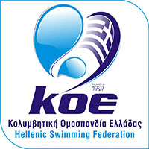
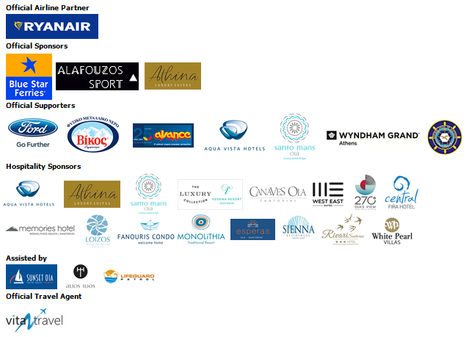
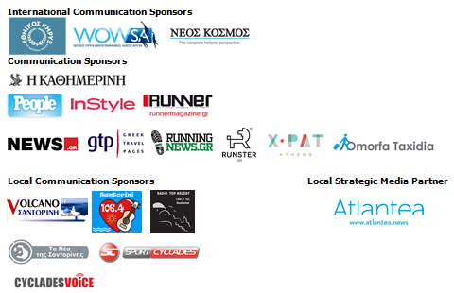

Information for editors:

Press Office Contact:
Tel.: +30 210 9343020, fax: +30 210 9316505
e-mail: pr@activemedia.com.gr

Website: www.santorini-experience.com
Facebook Page: https://www.facebook.com/SantoriniExperience
Twitter Account: https://twitter.com/Sant_Experience
YouTube Channel: https://www.youtube.com/channel/UCGconq7q45TYim8qFg71XlA
Instagram Page: https://www.instagram.com/santoriniexperience/

