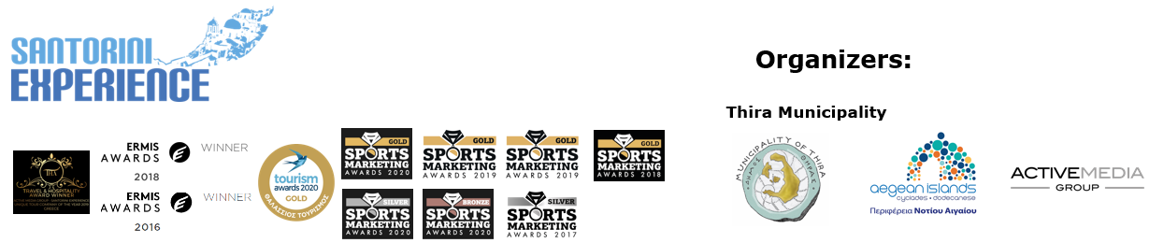

**PRESS RELEASE**

**The two-time European champion Antigoni Drisbioti**

**at Santorini Experience 2022**

**The schedule & event’s discounts**

**Athens, September 19, 2022 – Santorini Experience 2022** is approaching for its **6th year,** ready to highlight the **cultural, sports and sea tourism** of the island. Featuring new spectacular running routes together with the established and unique open water swimming route, amateur and professional swimmers and runners from all over the world will visit **Santorini** on **September 23-25.**

**The Daedalic Kore display is now a fact**

The Daedalic Kore of Thira, the rare masterpiece of Greek sculpture dated back in the 7th century BC, which was discovered in 2000 by the archaeologist Charalambos Sigalas from Thira, during a rescue excavation in the cemetery of the ancient city of Thira, in southeastern Sellada, is now the central exhibit of the under-renovation **Archaeological Museum of Thira.** The public has now the opportunity to admire archaic Kore made of white Naxian marble of supernatural size, with height 2.30m and weight 750 kg, at the Archaeological Museum of Thira, in Fira. At the same time, significant athletes will convey the **message of culture, emitted by the Daedalic Kore of Thira,** through their presence at this year’s **Santorini Experience.**

**The European champion in race walking will attend the event**

The two-time European gold medalist and Olympian in race walking **Antigoni Drisbioti,** who honored our country and made us all proud with her successes at the European Athletics Championships in Munich, will be present at Santorini Experience for the first time.

The event will also be honored with the presence of the Dutch gold and silver Olympic medalist, world champion and 8-time European champion in open water swimming **Sharon van Rouwendaal,** the British two-time silver Olympic medalist in open water swimming **Jazz Carlin** and the Greek world champion in open water swimming and athletes’ representative in the Hellenic Swimming Federation’s Board of Directors, **Kelly Araouzou.**

The running activities are graced with the participation of one of the top names in Greek athletics, the Olympian and European champion in the 400m. with hurdles **Periklis Iakovakis** and the Greek-American ultramarathon **Konstantine Dean Karnazes** who will promote and spread the message of Santorini’s sports and cultural tradition with his participation, in the United States of America and around the world.

**30% discount on ferry tickets with Blue Star Ferries**

Those who visit Santorini by ferry for the 6th Santorini Experience, will have the opportunity for another year to travel with the safety and comfort of **Blue Star Ferries,** the event’s **Official Sponsor.** The top Greek shipping company offers a **30% discount for each participant** on all non-cabin seats, as well as a **30% discount on their vehicles** (cars & motorcycles), while participants are entitled to a discount for **additional 3 people** each from **Piraeus, Cyclades & Dodecanese to Santorini** with return.

**Run in the “Daedalic Kore of Thira” Half Marathon**

The **“Daedalic Kore of Thira” Half Marathon** will take place on **Saturday, September 24, 2022,** at **07:45am** starting from the **Holy Church of Saint George** in **Oia,** passing through the enchanting areas of **Imerovigli** and **Fira** and finish back to Oia.

**Run the 5km “Aristides Alafouzos”**

The new addition to this year’s schedule concerns the running event and specifically the **5km route** that will be held on **Friday, September** **23** at **18:00pm,** at **Akrotiri** in Santorini, where one of the most important prehistoric settlements in Europe is located, which has been partially excavated and has revealed great cultural specimens. Starting from the church of **Saint Raphael,** runners will head towards the **Akrotiri Lighthouse,** one of the oldest lighthouses in Greece built in 1892 and reach the westernmost point of the island, returning to Saint Raphael for their finish. The running races are co-organized with **AS Ifestos Thira** and **EAS SEGAS Cyclades.**

**Participate in the 1.5 miles “L & E Nomikos” Open Water Swimming route from the Volcano**

Athletes will swim in the **unique 1.5 miles (2.4 km) “L & E Nomikos” open water swimming route** of **Santorini Experience** that will be held on **Sunday September 25, 2022,** at **10:00am,** from the volcano to the old port of Fira, **with the approval of the** **Hellenic Swimming Federation.** The route was named in honor of the benefactor Evangelos Nomikos and his wife, in whose memory the “Loula & Evangelos Nomikos” Foundation was created, which built the visionary Cable Car 40 years ago. The route has been designed by the race’s technical director with Olympic and world championship swimming distinctions, **Nikos Gemelos.**

**Receive Participation Kit from Alafouzos Sport Store**

Participants will be able to pick up their participation kit from **Alafouzos Sport** store in Fira, the event’s **Official Sports Store.** The service hours for the participants will be **from 09:00am** to **21:00pm** on **Friday September 23** and **Saturday September 24.**

Discover the **full schedule** here**:** [**https://bit.ly/3eKmEfM**](https://bit.ly/3eKmEfM)

More details about the **routes** and their **technical characteristics** here: [**https://bit.ly/3R84gfq**](https://bit.ly/3R84gfq)

**Online registration is closed – Registrations at Alafouzos Sport store from September 22 – Free registration for Thira Municipality Citizens**

The **online registration** for the impressive **“Daedalic Kore of Thira” Half Marathon,** the **5km “Aristides Alafouzos”** and the **1.5 miles “L & E Nomikos”** **Open Water Swimming is closed but participants can still register** at **Alafouzos Sport, the event’s Official Sports Store, from Thursday September 22, 2022. The** **citizens of Thira Municipality** can participate **for free.**

For **group registrations of 10 people or more, a 20% discount applies.** For more information, please contact the event organizers.

**Metaxa Hospitality Group - Santo Maris** and **Blue Star Ferries** are the event’s **Official Sponsors.**

**Seaside Santorini** is the **Signature Sponsor.**

**Vikos Natural Mineral Water** is the event’s **Official Water.**

**Alafouzos Sport** is the **Official Sports Store.**

**Luanvi** is the **Official Sports Supplier.**

**Englobia** is the **Official Travel Partner.**

**Esperisma bar restaurant** and **Caldera Yachting** are the **Official Supporters.**

**Blue Island Rental, Trinacria, Travel to Greece by Med Shore Tours & Travel, Holiday Tours Santorini, Lux Bar Santorini, The Dolphins restaurant, Skala Restaurant** and **Volcano View** are the event’s **Partners.**

The event is **assisted by**: **Santorini Boatmen’s Association, Lifeguard Patrol, Voluntary Lifeguards of Santorini** and **Erotokritos Cretan Bakery.**

**Book your package in Santorini with discount**

**Englobia,** as the event’s **Official Travel Partner,** takes care of the participants’ best possible service and their accommodation in Santorini during the event. Those interested can directly book their package for Santorini Experience, which includes accommodation and car rental. Check here for more information about the **packages:** <https://www.englobia.com/vacation-packages/santorini-experience-travel-package>. Take advantage of the **10% discount** offered by Englobia on its packages, using the **discount coupon** at the following link: <https://www.englobia.com/santorini-experience-2022>

Up to this point, this year’s event is enormously supported by the following **hospitality sponsors / hotels: Santo Maris Oia Luxury Suites & Spa, Canaves Oia,** **Nous Santorini, Kivotos Santorini, Fanouris Condo, Apeiron Blue Santorini Luxury Suites, West East Suites, Sienna Eco Resort, White Pearl Villas, De Sol Hotel & Spa, The Tsitouras Collection, 270 Oia’s View Lydia’s House Santorini, El Greco Resort & Spa, Santorini Palace, Vedema - A Luxury Collection Resort Santorini, K & K Unique Holiday Homes, Andronis Colombo’s Beachfront Hotel, Loizos Stylish Residences, Santo Houses, Holiday Beach Resort, Marvarit Suites, Glaros Hotel Santorini, Athina Luxury Suites.**

Check their**special offers**here:[**https://bit.ly/3AwF0Is**](https://bit.ly/3AwF0Is)

**Santorini Experience** takes place this year for the **6th year** and is organized by the **Municipality of Thira,** the **Region of South Aegean** and the Sports Tourism department of **ActiveMedia Group.**

The event will be held **under the auspices** of the **Ministry of Tourism,** the **General Secretariat of Sports of the Ministry of Culture and Sports** andthe **Greek National Tourism Organization** with the approval of **Hellenic Swimming Federation.**

Santorini Experience has joined the Greek actions of the **#BeactiveHellas 2022** program of the European Commission and is held **under the auspices of the General Secretariat of Sports.**

Sports Production: **ActiveMedia Group**

More information: [www.santorini-experience.com](http://www.santorini-experience.com/)

#SantoriniExperience

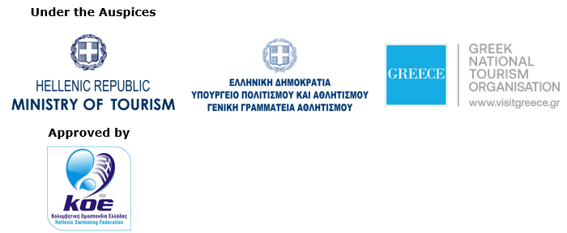



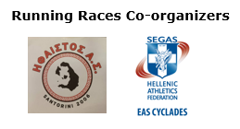

**Information for the editors:**

**Press Office Contact:**

Tel.: +30 210 9343020

e-mail: [pr@activemedia.gr](mailto:pr@activemedia.gr)

**Website:** [www.santorini-experience.com](http://www.santorini-experience.com/)

**Facebook Page:** <https://www.facebook.com/SantoriniExperience>

**Instagram Page:** <https://www.instagram.com/santoriniexperience/>

**Twitter Account:** <https://twitter.com/Sant_Experience>

**YouTube Channel:** <https://www.youtube.com/channel/UCGconq7q45TYim8qFg71XlA>