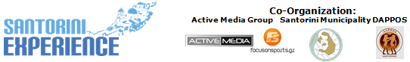
Under the Auspices of the Greek National Tourism Organization
& the Hellenic Swimming Federation

PRESS RELEASE
Athens, September 20, 2016

Spyros Gianniotis & the elite athletes of the open water swimming in “Santorini Experience 2016”!

Complete your registration in Santorini Experience & receive 50% discount on your ferry tickets with Blue Star Ferries!

“Santorini Experience” alongside Maria Sampanidou

“Santorini Experience 2016”, is just two weeks away from its implementation and the interest of people is now peaked for the greatest sporting weekend, giving their appointment in the island of Santorini, on October 7-9, 2016!

With the support of the Municipality of Santorini, the Municipal Sports Cultural Environmental Organization of Santorini (D.A.P.P.O.S.) and for the first time with the kind support of the Greek National Tourism Organization, “Santorini Experience” is already counting a record in participations, from Greece and abroad, while a record is also achieved in the occupancy of the hotel accommodations from the hospitality sponsors that support the event throughout the second weekend of October!

Spyros Gianniotis and top open water swimmers from the Greek national open water swimming team will participate in “Santorini Experience 2016”!
The Silver Olympic medalist & World Champion in open water swimming will be in Santorini for a second consecutive year and together with him, the top names of the Greek national open water swimming team. Among them, the World Champions in open water swimming, Kelly Araouzou and Antonis Fokaidis, the European Champion, Giorgos Arniakos and the Champion Dimitris Negris. Swimming clubs and athletes from all over Greece will be in Santorini with the support of the Hellenic Swimming Federation (the event is held under the Auspices of the Federation) and the presence of its President, Mr. Dimitris Diathesopoulos.

The access to the volcanic island of the Cyclades is now even easier with the support of Blue Star Ferries which offers 50% discount on your ferry tickets during the days of the event! The procedure is easy! Further to the completion of your registration at Santorini Experience 2016, interested parties should contact for their reservations the GELASAKIS STC agency in Piraeus at the following number 210 4222440. The 50% discount on your tickets and your vehicles is ONLY valid if you have completed your registration, so that the organizers will be able to inform the agency accordingly. Each person who has completed his/her registration is entitled to the same discount for 3 more people (if these are his/her escorts) or for 4 people (if these are family members). Those who are interested in buying ferry tickets should receive their tickets at least two days before their departure. Important note: discount depends on availability (based on the occupancy and the available tickets) and is valid for travels that will be implemented during the days of the event.

Further to the flights added by the official airline partner, Ryanair, offers and benefits from the sponsors of the event are still running and can be found in the following link: http://santorini-experience.com/event_offers.html

Running and swimming are highlighted for one more year in “Santorini Experience”. On Saturday October 8th 2016, professional and amateur runners will be able to run and live the adrenaline of Caldera! The starting time for both 10 km and 15 km routes is at 08:15 am in the morning, while the starting time of the 5km route will take place at 11:00. All routes start from the desalination plant in Oia.
Moreover, on Sunday October 9th 2016, professional and amateur swimmers will be able to sense the eruptive atmosphere of the volcano with the impressive view of the island in front of them! The starting time of the unique swimming route of 1.5 mile (2.4 km) of “Santorini Experience”, will take place at 10:00 am, from the volcano to the old port in Fira.

Registrations in swimming and running will continue until September 30th through the official page of the event in the following link: http://activemedia.com.gr/product/santorini-experience-2/ or alternatively at Alafouzos Sport store at Fira (in Santorini), the official sponsor of the event supporting it for a second consecutive year. From Thursday, October 6 to Saturday, October 8, 2016, all participants will be able to receive their numbers from Alafouzos Sport store (hours: 09:00-21:00). Alternatively the running participants may also receive their numbers one hour before the start of their route on Saturday October 8, 2016, from the desalination plant in Oia while the swimming participants may also receive their numbers one hour before their start from the old port in Fira.

“Santorini Experience” alongside “Iron Samba”!
Maria Sampanidou or «Iron Samba», as she is called by her friends in the world of sports, gives the most crucial fight after a severe stroke she suffered and needs the help by all of us!
The athlete, suffered from her young age by the autoimmune syndrome called Hughes, which causes blood clots; and a change in her drug treatment caused a clot in the blood and as a result she paralyzed on one side and is in partial aphasia. Maria participated last year in “Santorini Experience” and had signed up to participate for this year too. The organization feels obliged to stand next to her in this difficult time of her life. Part of the “Santorini Experience” revenues will be given to the Give&Fund created to support Maria’s rehabilitation race. Anyone can support Maria Sampanidou through the following page: http://www.giveandfund.com/giveandfund/project/Ironsamba

The occupancy of the hotels is already in high standards that is why you will have to move quickly and get advantage of the special prices offered in one of the hospitality sponsors of the event. The most recent entries in the hospitality sponsors of the event are Vedema A Luxury Collection Resort Santorini, Sunday Suites Santorini and Maistros Village Hotel while for more information you may also address your request to Aqua Vista Hotels, Santorini Hoteliers Association, Meltemi Hotels & Resorts, Athina Luxury Suites, Santorini Secret Suites & Spa, Caldera Collection, West East Suites, 270 Oia's View, White Pearl Villas, Central Fira Hotel, Memories Hotel, Loizos Stylish Residencies, Esperas and Sienna Residencies which are available in the following link: http://santorini-experience.com/event_accommodation_en.html. The page will be daily enriched with new supporters.

“Santorini Experience” will be held under the auspices of the Greek National Tourism Organization and the Hellenic Swimming Federation and will receive the international promotion of FOX Sports TV network of FOX Networks Group, participating in this year's event as the Official Broadcaster.

“Santorini Experience” is a collaboration between the Municipality of Santorini, the Municipal Sports Cultural Environmental Organization of Santorini (D.A.P.P.O.S.) and Active Media Group.

Promo Video: https://youtu.be/DxJGHZj6hv8

Official Sponsors: Alafouzos Sport, Blue Star Ferries, With the Kind Support of the Greek National Tourism Organization, Santorini Boatmen Union
Official Airline Partner: Ryanair
Official Supporters: Ford Motor Hellas, “Vikos” Natural Mineral Water, Avance Rent A Car, Aqua Vista Hotels, Saucony, Arena, Village Cinemas, Santorini Yachting Club, Passagio Santorini
Official Broadcaster: FOX Sports
Hospitality Sponsors: Santorini Hoteliers Association, Meltemi Hotels & Resorts, Athina Luxury Suites, Santorini Secret Suites & Spa, Vedema A Luxury Collection Resort Santorini, Sunday Suites Santorini, Caldera Collection, West East Suites, 270 Oia's View, White Pearl Villas, Central Fira Hotel, Memories Hotel, Loizos Stylish Residencies, Esperas, Maistros Village Hotel, Sienna Residencies
Assisted by: Diana “exoplizein”
With the Kind Support & Under the Auspices of the Greek National Tourism Organization
Under the Auspices of the Hellenic Swimming Federation
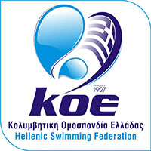
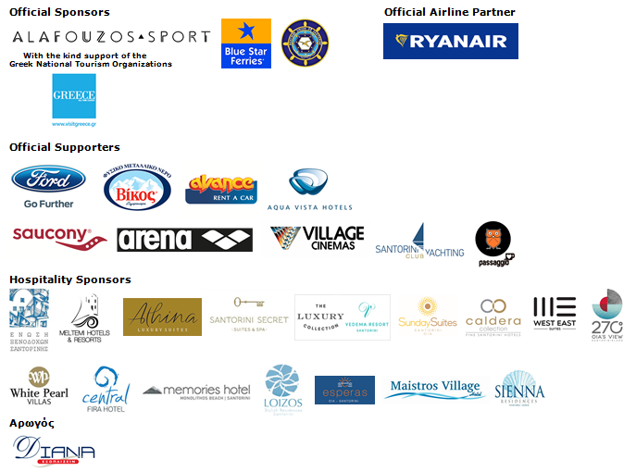

Website: www.santorini-experience.com
Facebook Page: https://www.facebook.com/SantoriniExperience
Facebook Event: https://www.facebook.com/events/969713156476789/
Twitter Account: https://twitter.com/Sant_Experience
YouTube Channel: https://www.youtube.com/channel/UCGconq7q45TYim8qFg71XlA
Instagram Page: https://www.instagram.com/santoriniexperience/
Google+ Page: https://plus.google.com/u/0/b/110202716050196467073/110202716050196467073
Hashtag: #SantoriniExperience

