

Under the Auspices of the Greek National Tourism Organization
& the Hellenic Swimming Federation

PRESS RELEASE

The schedule of Santorini Experience 2017!

Running takes place on Saturday 7/10 & swimming on Sunday 8/10!

Athens, August 30 2017. The top sports tourism event “Santorini Experience” organized for the 3rd consecutive year in the enchanting Santorini on October 6-8, 2017 is ready to excite all professional and amateur swimmers and runners from around the world!

This year’s schedule begins on Friday, October 6th 2017 with a focus on children. More specifically at 10:00am in the morning the 1km kids running race will be held at the Indoor Hall DAPPOS, in Fira.
On Friday, at 12:00pm the established Meet & Greet will be held with the presence of silver Olympic medalist Alexandros Nikolaidis, the Olympic & World Champion in 400m. with hurdles Periklis Iakovakis, the World Champion in open water swimming Kelly Araouzou as well as top athletes from the Greek open water national team, at Alafouzos Sport store (official sponsor of the event supporting “Santorini Experience” for a third year in a row) at Fira.
Respectively, the twice Silver Olympic Medalist, Alexandros Nikolaidis will undertake for one more year to introduce the secrets of TaeKwonDo martial art to beginners (at 15:00pm) and advanced athletes (at 16:00pm) at the Indoor Hall of DAPPOS, at Fira.

Running and swimming are the dominant activities in “Santorini Experience” for another year!
On Saturday, October 7, 2017, professional and amateur runners will have the chance to run and live the adrenaline of the Caldera with the starting of the 10km and 15km running routes taking place at 08:15am in the morning, and the starting of the 5km “Aristides Alafouzos” route at 11:00am. All routes start from the desalination plant in Oia.

On Sunday October 8, 2017, professional and amateur swimmers will be able to feel their energy erupt and the atmosphere of the volcano with the imposing view of the island in front of them! The 1.5 mile (2.4km) unique swimming race of “Santorini Experience”, will start at 11:00am from the volcano and finish at the old port in Fira. The swimming route will be carried out with absolute safety in the magical waters of Santorini, under the auspices of the Hellenic Swimming Federation and under the technical direction of the Federal Technical Coach, Nikos Gemelos who has designed this unique route. The race will be held with the participation of the World Champion in open water swimming, Kelly Araouzou as well as athletes from the Greek open water swimming national team. You may find the detailed schedule at the following link: http://www.santorini-experience.com/en/event-info/schedule/schedule-2017.html

Registrations in swimming and running continue with an undiminished pace until September 28th through the official page of the event in the following link: http://activemedia.com.gr/product/santorini-experience-2017/ or at the official sponsor Alafouzos Sport store at Fira (in Santorini). From Thursday, October 5 to Saturday, October 7, 2017, all participants will be able to receive their numbers from Alafouzos Sport store (hours: 09:00-21:00). Alternatively the running participants may also receive their numbers one hour before the start of their route on Saturday October 7, 2017, from the desalination plant in Oia while the swimming participants may also receive their numbers one hour before their start on Sunday October 8, 2017, from the old port in Fira.

Samsung will stand by the event’s side for the first time as the official technology partner, with the eco-system of Samsung Galaxy devices. Samsung Galaxy S8 and S8+, combined with the camera Gear 360 and Gear VR, will enrich the experience of the participants and the spectators of the event with unique 360 degrees content.

VitaNTravel, as the official travel agent of the event, will take care and assist all athletes and escorts with information about the ferry routes, ferry tickets, car rentals and accommodation in the island. For more information visit: http://vitantravel.gr/home/

The hospitality sponsors supporting the event are: Aqua Vista Hotels, Athina Luxury Suites, Santo Maris Oia Luxury Suites & Spa, Vedema A Luxury Collection Resort Santorini, Canaves Oia, West East Suites, Desiterra Luxury Suites & Villas, 270 Oia's View, Central Fira Hotel, Memories Hotel, Loizos Stylish Residencies, Fanouris Condo, Monolithia Hotel, Esperas Santorini, Sienna Residencies, Hotel Rivari Santorini, White Pearl Villas.

“Santorini Experience” will take place under the auspices of the Greek National Tourism Organization and the Hellenic Swimming Federation with the co-organization of the Municipality of Santorini, DAPPOS and Active Media Group.

Official Hashtag: #SantoriniExperience

Official Airline Partner: Ryanair
Official Sponsors: Blue Star Ferries, Alafouzos Sport, Athina Luxury Suites
Official Technology Partner: Samsung
Official Supporters: Ford Motor Hellas, “Vikos” Natural Mineral Water, Avance Rent A Car, Aqua Vista Hotels, Santo Maris Oia Luxury Suites & Spa, Wyndham Grand Athens, Santorini Boatmen Union
Hospitality Sponsors: Aqua Vista Hotels, Athina Luxury Suites, Santo Maris Oia Luxury Suites & Spa, Vedema A Luxury Collection Resort Santorini, Canaves Oia, West East Suites, Desiterra Luxury Suites & Villas, 270 Oia's View, Central Fira Hotel, Memories Hotel, Loizos Stylish Residencies, Fanouris Condo, Monolithia Hotel, Esperas Santorini, Sienna Residencies, Hotel Rivari Santorini, White Pearl Villas
Assisted by: Sunset Oia Sailing Cruises, Alios Ilios, Lifeguard Patrol, National Lifeguards of Santorini, Aegean Divers
Official Travel Agent: VitaNTravel

Under the Auspices of the Greek National Tourism Organization
Under the Auspices of the Hellenic Swimming Federation
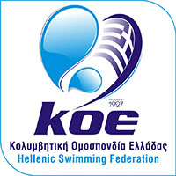

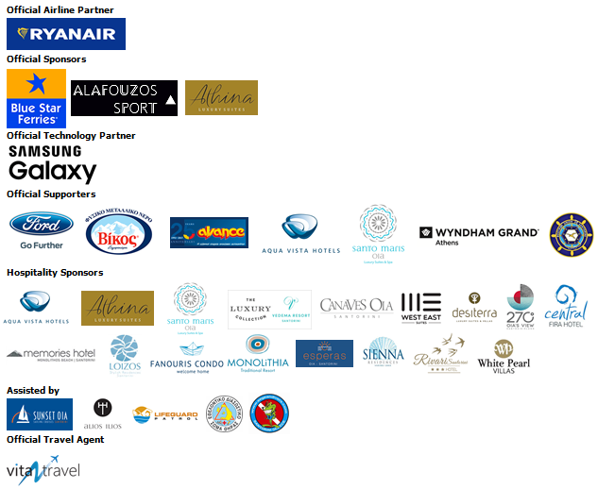



Information for the editors:

Press Office Contact:
Tel.: +30 210 9343020, fax: +30 210 9316505
e-mail: pr@activemedia.com.gr
Website: www.santorini-experience.com
Facebook Page: https://www.facebook.com/SantoriniExperience
Twitter Account: https://twitter.com/Sant_Experience
YouTube Channel: https://www.youtube.com/channel/UCGconq7q45TYim8qFg71XlA
Instagram Page: https://www.instagram.com/santoriniexperience/

