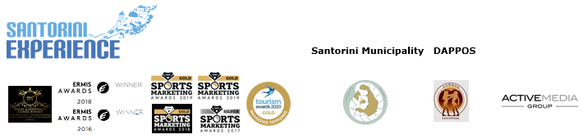

**PRESS RELEASE**

**Santorini Experience is postponed to October 1-3, 2021**

**Athens, September 29, 2020 –** The top sports event **Santorini Experience**, which endorses the volcanic island of Cyclades for its sports tourism is **postponed to October 1-3, 2021.** Despite the dynamic efforts and the provision of all necessary permits, licenses and approvals of health protocols for the safe and smooth implementation of the Santorini Experience in 2020, the event, which has been successfully assigned for the last six years to Active Media Group by the Municipal Sports Cultural Environmental Organization of Santorini (DAPPOS [www.dappos.gr](http://www.dappos.gr)), will not take place in 2020.

**Santorini Experience,** is the annual sports appointment of **Santorini,** attracting professional and amateur athletes from Greece and abroad, while presenting unique **running** activities with a breathtaking view, on the path that connects Oia with Fira and an **open water swimming** race from the volcano to the old port of Fira. The appointment for the award-winning sea tourism event, with the running and swimming audience, is renewed for **October 1-3, 2021.**

**Approval of Health Protocols**

Santorini Experience had received the **approval of the Hellenic Swimming Federation** for the implementation of the swimming event and the **approval of the Hellenic Athletics Federation (SEGAS)** for the implementation of the running races.

At the same time, Active Media Group had acquired the **approval of the Health Scientific Committee of the General Secretariat of Sports,** through the strict distinct health protocols it designed for running and swimming respectively, while successfully passing the tests of the **World Health Organization** and **World Athletics.**

**Registrations: Refund or Transfer of Participations to 2021**

Active Media Group, always prioritizing the best service of its participants, offers the **possibility of** a **refund** to all runners and swimmers who had already completed their registration for Santorini Experience 2020 or alternatively the possibility of **transferring their participation to the 2021** **event.**

Participants who had completed their registration will receive additional **information within the following week,** regarding the possibility of transferring their registration to the respective event of 2021 or its cancellation and refund of their registration fee.

**A big thank you**

**Thank you is a magical word, with tremendous power, full of love, affection, kindness, humility and gratitude. That is why we will repeat it several times.**

We wish to thank the people of Santorini, those who proved what solidarity, ethics, support, innovation, sustainability, creativity, quality and vision mean, when society needed it, when Greek tourism needed it.

We especially wish to thank the foreign participants, the foreign champions, the swimmers’ groups from abroad and the foreign journalists for their patience and understanding.

We would like to thank the members of the national swimming team, the Olympic medalists and world champions, the technical directors of the races and all professional and amateur participants for the interest they **showed until the very last minute** to take part in the top sea tourism event.

Active Media Group wishes to express a big thank you to all sponsors, supporters and partners, all the Greek and foreign media who stood alongside throughout the year and thank them for all their physical and ethical support.

An event that managed to achieve something unprecedented, to unite major companies of the island, top entrepreneurs, not only of the Greek tourism industry, but in a worldwide scale. An event that was rewarded for the excellence of its best practices at the Greek Tourism Awards, the Sports Marketing Awards and the Ermis Awards receiving foreign distinctions and awards, respectively.

We are deeply sorry that just three (3) days before the start of the event we need to postpone it. An event that we undertake for six consecutive years as a contractor by the Municipal Sports Cultural Environmental Organization of Santorini (DAPPOS), having prepared everything for its **implementation,** from the ending of 2019 until today and **having the assent of the competent body from the state,** that is, the approval of the Health Scientific Committee of the General Secretariat of Sports, the only competent authority for the approval of the event’s health protocol in conditions of the Covid-19 pandemic.

In the aspect of healthcare, **no consent or any additional action is required,** nor the ratification by another body (e.g. Ministry, National Public Health Organization [EODY]), as the Health Scientific Committee of the General Secretariat of Sports is the competent authority for sports events. In fact, the Committee is in constant contact with the sports committee of EODY for all current developments and more. We should not forget that when we talk about competence, we are talking about legal authority and the most fundamental form of the concept of competence is the constitutional distinction of the functions of a State.

Events will continue to take place, as they were recently held in Evia, Rethymno, Ioannina, as we all must learn to live in the new normal, with safety rules and strict protection measures, as set by the state.

Without fear, but with logic.

We close with the same video that we opened the year 2020 and set an appointment for 2021:

<https://youtu.be/JI9skJenaEc>

**Athina Luxury Suites, Vikos Natural Mineral Water** and **Blue Star Ferries** were the event’s **official sponsors.**

**Luanvi** was the event’s **official sports supplier**.

**Boatmen Union Santorini** was the event’s **official supporter.**

**Avance** was the **official car rental partner.**

**Messinian Spa** was the event’s **official beauty partner.**

**SKAI** was the **premium TV partner.**

**24MEDIA** was the **premium media partner.**

**Red Swim Academy, Swim Academy, Leandros** and **Swimmingclub.gr** were the **athletic partners** of Santorini Experience.

The event was **assisted** by **Lifeguard Patrol, Voluntary Lifeguards of Santorini, Atlantis Dive Center, Santorini Nautical Club** and **Caldera Yachting.**

**Tangopapas.com** was the event’s **travel partner.**

In these **difficult times**, this year’s event was supported with **amazing offers and prices** by the following **hospitality sponsors:** **Athina Luxury Suites, Santo Maris Oia Luxury Suites & Spa, Canaves Oia, Katikies Santorini, Andronis Arcadia, West East Suites, K&K Unique Holiday Homes, Folia Bianca,** **Cocoon Suites, Marvarit Suites, Iriana Suites, Nefeles Luxury Suites, Sienna Resort, Santo Houses, Memories Hotel, 270 Oia’s View, Cori Rigas Suites, Uma Ray Suites, Loizos Stylish Residencies, Monolithia, Fanouris Condo, Epavlis Hotel, Iokasti Villa, Olive Cave Houses, Panorama Boutique Hotel, Esperas Santorini** and **Santorini Hospitality**.

**Santorini Experience** had joined the Greek actions of the **#BeactiveHellas 2020** programme of the European Commission which is held **under the auspices of the General Secretariat of Sports.**

Running races were organized along with **AS Ifestos Thiras** and **EAS SEGAS Cyclades Region.**

The event joined the swimming community **Global Swim Series (GSS)** and the running community **World’s Marathons.**

**#santoriniexperience**

**Information for the editors:**

**Press Office Contact:**

Tel.: +30 210 9343020, fax: +30 210 9316505

e-mail: [pr@activemedia.com.gr](mailto:pr@activemedia.com.gr)

**Website:** [www.santorini-experience.com](http://www.santorini-experience.com/)

**Facebook Page:** <https://www.facebook.com/SantoriniExperience>

**Instagram Page:** <https://www.instagram.com/santoriniexperience/>

**Twitter Account:** <https://twitter.com/Sant_Experience>

**YouTube Channel:** <https://www.youtube.com/channel/UCGconq7q45TYim8qFg71XlA>

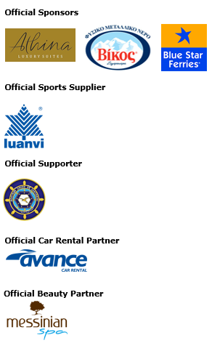

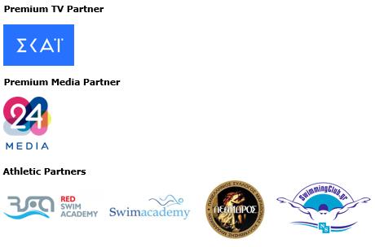

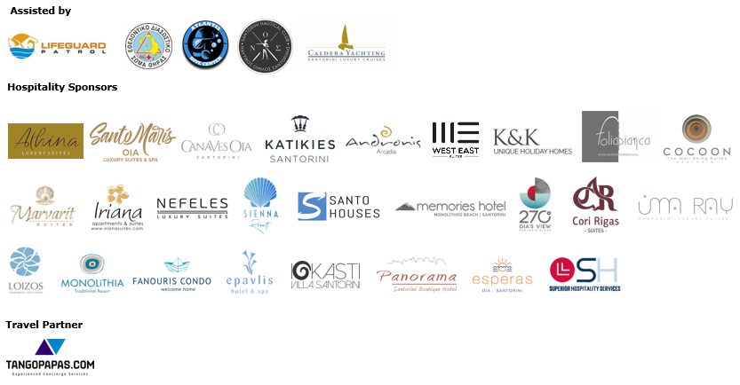







**Member of:**





**Approved by the Hellenic Swimming Federation**

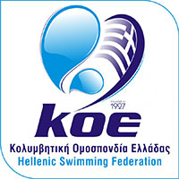

**10km running race was co-organized with AS Ifestos Thiras and EAS SEGAS Cyclades Region and was approved by the Hellenic Athletics Federation (SEGAS)**





