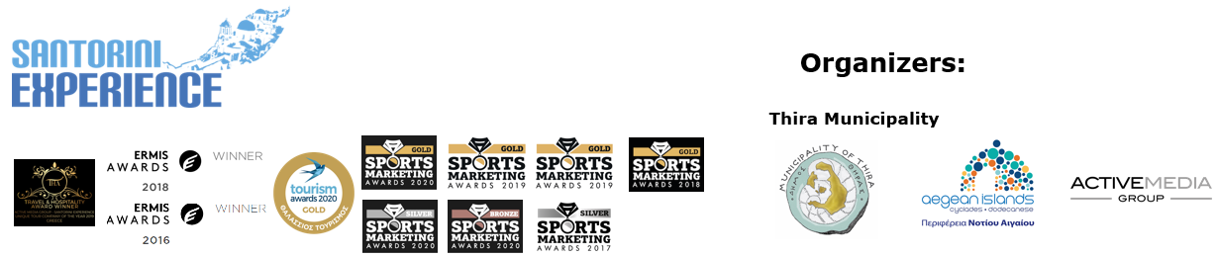

**PRESS RELEASE**

**Santorini Experience 2022: Culture and Sports Tourism**

**Drisbioti, Rouwendaal, Carlin, Iakovakis and other world stars were in Santorini**

**Athens, 27 September 2022 - The Santorini Experience, a great event celebrating the** cultural, sports and marine tourism of one of the world's top destinations, is back in full force after two years of pandemic. Against the backdrop of the unique Aegean images of Fira, Oia, **Imerovigli**, **Akrotiri** and the **volcano**, the new impressive new running courses and the established and unique open water swimming course, brought together in **Santorini**, amateur and professional swimmers and runners from **22 countries** including the **USA, Brazil, Uruguay, South Africa, South Africa, Nigeria, Jamaica, India, Great Britain, Germany, France, India, Great Britain, Germany and France on September 23-25.**

**Promotion of Culture with the Daedalian Daughter of Thera**

With every solemnity, in the presence of the **Deputy Minister of Tourism, Ms. Sofia Zacharaki**, the Mayor of Thera**, Mr. Antonios Sigalas and the Deputy Mayor of Thera and Head of Culture, Ms. Sophia Kitsou visited the Daedalian Daughter of Thera**. The rare masterpiece of Greek sculpture of the 7th century BC, which was brought to light in 2000 by the Thera archaeologist Charalambos Sigalas, during a rescue excavation in the cemetery of the ancient city of Thera, in southeastern Sella, is now the central exhibit of the **Archaeological Museum of Thera,** which is under renovation. The world public now has the opportunity to admire the supernaturally sized archaic maiden of white Naxian marble, 2.30 m high and weighing 750 kg, 22 years after its discovery at the Archaeological Museum of Thera, in Fira, which is currently under renovation.

In the context of her visit to Santorini, **the Deputy Minister of Tourism, Mrs. Sofia Zacharaki** said: "I *had the great pleasure to be in Santorini on September 23-25, at an mblematic sports tourism event, the Santorini Experience, which has been revived after two years of absence and is now established as a major sporting event, uniting culture and sport, with many participating athletes from all over the world. The participants even had the opportunity to tour the Santorini Museum, which is under renovation, and admire the Daughter of Thera, a unique cultural reference point not only for the island but also for Greece and the world. Special forms of tourism, such as sports and cultural tourism, highlight the fact that all destinations in our country, even the most popular ones like Santorini, have the potential to further diversify their tourism product, giving even more quality choices to the visitor. It is a central priority of the Ministry of Tourism to support events such as the Santorini Experience, which we are delighted to sponsor, reflecting our willingness to give practical support to similar initiatives throughout the country. Greece and Greeks, with this year's successful tourist season, we have shown that we can not only overcome the global crises, but also exceed all expectations. The bet for the future is that tourism growth is sustainable, balanced and of high quality. And in this, the role of institutions like the Santorini Experience is crucial."*

At the same time, **the Mayor of Thera, Mr. Antonios Sigalas** said, among other things, "*We had a very successful event that made a new start and a dynamic presence in culture. I am very pleased that the Half Marathon was named the Daedalic Daughter of Thera and today we are at the Archaeological Museum of Santorini where we had the honour and pleasure to accompany the Deputy Minister of Tourism Mrs. Zacharaki to enjoy this amazing work. The Municipality of Thera, which places a very great emphasis on tourism, but more so on culture and sports, has once again demonstrated the success of its investment program with the Ministry of Culture, which supports all these actions and the completion of this site so that Kori can continue to be visited for years to come. Many thanks to everyone who contributed to this great success."*

**World Class Names at the Santorini Experience 2022**

**Great athletes conveyed the message of culture that the Daedalian Daughter of Thera sends to the world through their presence at this year's Santorini Experience.**

**The athletes who were in Santorini and were honoured by the event were:**

- The two-time European gold medalist and Olympic gold medalist in gymnastics **Antigoni** **Drisbioti**, who honoured our country and made us all proud with her successes at the European Athletics Championships in Munich

- The Dutch Olympic gold and silver medalist, world champion and 8 times European champion in open water swimming Sharon van Rouwendaal,

- British two-time Olympic silver medallist in open water swimming Jazz Carlin

- One of the top names in Greek athletics, Olympic and European 400m hurdles champion **Pericles Iakovakis**

- and the Greek-American ultra-marathon runner **Konstantinos Karnazis,** who with his participation promoted and spread the message of sport and culture of Santorini in the United States of America and around the world.

**New impressive routes in running**

A new route was included in the 2022 **5km** programme as well as a **Half Marathon** for the first time.

Also, the participants of the **5km "Aristides Alafouzos**" saw for the first time on **Friday 23 September,** the image of a different Santorini, next to one of the most important prehistoric settlements in Europe, at **Akrotiri** and a view different from the one we are used to, but equally magnificent.

Starting from the **church of Agios Rafael**, the runners headed towards the lighthouse of Akrotiri, one of the oldest lighthouses in Greece, built in 1892, reaching the westernmost point of the island, returning back to Agios Rafael for the finish. At the start of the race were two-time European gold medalist and Olympic gold medalist in the marathon **Antigoni Drisbioti**, Olympic and European 400m hurdles champion **Pericles Iakovakis**, former international goalkeeper and European champion with the Greek national team **Antonis Nikopolidis** and EuroLeague Legend **Joe Arlauckas.**

**On Saturday 24 September 2022**, **the half marathon** "**Daedaliki** **Daughter of Thera**" took place, starting from the **Holy Church of Saint George in Oia**, passing through the enchanting areas of **Imerovigli** and **Fira** and finishing back in Oia. This route was named "Daedalian Daughter of Thera", after the unique archaeological find dating back to 640 BC.

The two road races were co-organized with **AS Hephaestus of Thera** and the **Cyclades** **SEGAS**.

**The best swimming route in the world**

On **Sunday 25 September,** the participating athletes swam **the unique 1.5 mile (2.4 km) open water swimming course "L&E Nomikos" of the Santorini Experience,** which was held from the volcano to the **old port of Fira** with the imposing view of the island in front of them, with the approval of the **Hellenic Swimming Federation (Hellenic Swimming Federation).**

The swim was attended by international names such as the Dutch, Olympic gold and silver medalist, world champion and 8 times European champion in open water swimming **Sharon van Rouwendaal,** who also finished first, British, two-time Olympic silver medallist in open water swimming **Jazz Carlin**, as well as athletes of the national swimming team such as **Dimitris Negris, Stellina Applanti, Panagiotis Chiotis, Marina Triantafyllidi and Marina Pakou.**

The naming of the route was given in honour of the benefactor Evangelos Nomikos and his wife, in whose memory the eponymous Foundation was created, which built the visionary project of the Teleferik 40 years ago. The route has been designed by the technical director of the race, **Nikos Gemelos**, an Olympic and world champion in swimming. The races were honoured by the presence of the world champion in open water swimming and representative of the athletes in the COE Board, **Kelly Araouzou.**

See here the **results** of the **games**: [**https://bit.ly/3fq9a9D**](https://bit.ly/3fq9a9D)

**Swimming race with maximum safety**

The absolute safety of the race was greatly contributed by the **Thera Swimmers' Association,** which transported the athletes to the volcano and contributed to the smooth conduct of open water swimming, the **100 specialized escorts in the water**, mainly with the help of the **Lifeguard** **Patrol**, which in addition to the staff, had several rescue boats, the Volunteer Rescue Corps of Thera, **the Atlantis Dive Center**, **the Santorini Yacht Club**, and **Caldera Yachting**, all together having more than **30 boats next to the athletes**! The Santorini Experience took care of the swimmers by providing the safety life jacket that all swimmers were required to wear for safety. In fact athletes such as Rouwendaal and Carlin set an example by swimming with a **safety life jacket.**

At the end of the swim, **the technical director, Mr. Nikos Gemelos** said. *This year, however, is the year that the rule was reintroduced so that this event can be held every year again. This repetition helps us not to miss this great event and the experience is passed on to everyone. Events like the Santorini Experience bring people into swimming."*

All participants received a technical t-shirt with the new great design of the event by **Luanvi,** while those in swimming received a cap. **Santo Maris** **Oia** and **Blue Star Ferries** offered a sustainable backpack each, while at the end of each run **Erotokritos Cretan Bakery** took care of the guests with traditional flavours and of course Vikos, the hydration before, during and after the races.

**Rich parallel actions**

During the Santorini Experience, apart from the games and the visit to the Archaeological Museum of Thera, the following took place: an impressive Sunset Pilates Session with physical education teacher Mandi Persaki at Santo Maris Oia, Cocktails at Esperisma bar restaurant and Volcano View, a unique Boat Tour to the enchanting Santorini by Travel to Greece by Med Shore Tours & Travel, as well as rich meals at Seaside Santorini, Trinacria, The Dolphins and Skala restaurants.

**The sponsors on the side of the event**

The event could not have taken place without the undivided support of leading Greek businesses and hotels that are among the best hotels around the world.

The **Official Sponsors** of the event were **Metaxa Hospitality Group - Santo Maris**, which created the perfectly relaxing and rejuvenating Relax Day Spa package for optimal athlete performance, and **Blue Star Ferries**, which safely transported participants and offered significant discounts.

**Signature Sponsor** was **Seaside Santorini**.

**Official Water** of the event was natural mineral water **Vikos**, providing essential hydration and revitalization to all athletes.

**Official Sports Store** was **Alafouzos Sport**, serving as the registration center for the races.

**Official Sports Supplier** was **Luanvi**, ensuring athletes were properly outfitted.

**Official Travel Partner** was **Englobia**, offering special hospitality packages and discounts for worldwide service.

**Official Supporters** included Esperisma bar restaurant and Caldera Yachting.

**Partners** of the event included Blue Island Rental, Trinacria, Travel to Greece by Med Shore Tours & Travel, Holiday Tours Santorini, Lux Bar Santorini, Dolphins restaurant, Scala restaurant, and Volcano View.

**Supporters** of the event were the Santorini Boatmen's Association, Lifeguard Patrol, Volunteer Rescue Corps of Santorini, and Erotokritos Cretan Bakery.

In such a challenging period for hoteliers in Santorini, their response and participation as **Hospitality Sponsors** of the **Santorini Experience** is truly honorable and impressive. Over **30 hotel units** provided an unforgettable three-day experience for all their guests, which was widely acknowledged by everyone: **Santo Maris Oia Luxury Suites & Spa**, **Canaves Oia**, **Nous Santorini**, **Kivotos Santorini**, **Fanouris Condo by Meraki Collection**, **Apeiron Blue Santorini Luxury Suites**, **West East Suites**, **Sienna Eco Resort**, **White Pearl Villas**, **De Sol Hotel & Spa**, **The Tsitouras Collection**, **270 Oia’s View Lydia’s House Santorini**, **El Greco Resort & Spa**, **Santorini Palace**, **Vedema - A Luxury Collection Resort Santorini**, **K & K Unique Holiday Homes**, **Andronis Colombo’s Beachfront Hotel**, **Loizos Stylish Residences**, **Santo Houses**, **Holiday Beach Resort**, **Marvarit Suites**, **Glaros Hotel Santorini**, **Athina Luxury Suites**.

**Emphasis on Environmental Sustainability**

Throughout the Santorini Experience, the **Dive In Action** team ensured **a zero-footprint achievement** at all venues where this year's races took place.

The **Value of Volunteering**  
The support provided by the volunteers of the **Sports Management Society** of **Deree - The American College of Greece** was crucial to all activities.

The **Santorini Experience** was held this year for the 6th time and was co-organized by the **Municipality of Thira**, the **South Aegean Region**, and the **Sports Tourism Department of ActiveMedia Group**.

The event was held under the auspices of the **Ministry of Tourism**, the **General Secretariat of Sports of the Ministry of Culture and Sports**, and the **Greek National Tourism Organization**, with approval from the **Hellenic Swimming Federation**.  
The **Santorini Experience** was part of the Greek actions for the **#BeactiveHellas 2022** program of the **European Commission** and operated under the auspices of the **General Secretariat of Sports**.

The **Sports Production** was handled by **ActiveMedia Group**.

The hashtag **#SantoriniExperience** became the number one trend of the weekend, with people sharing unique moments from Santorini and the event on social media.

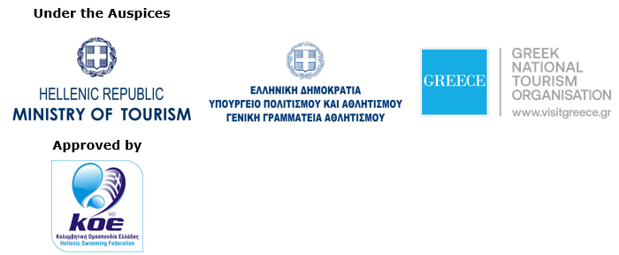



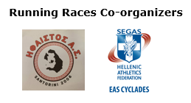

**Information for the editors:**

**Press Office Contact:**

Tel.: +30 210 9343020

e-mail: [pr@activemedia.gr](mailto:pr@activemedia.gr)

**Website:** [www.santorini-experience.com](http://www.santorini-experience.com/)

**Facebook Page:** <https://www.facebook.com/SantoriniExperience>

**Instagram Page:** <https://www.instagram.com/santoriniexperience/>

**Twitter Account:** <https://twitter.com/Sant_Experience>

**YouTube Channel:** <https://www.youtube.com/channel/UCGconq7q45TYim8qFg71XlA>