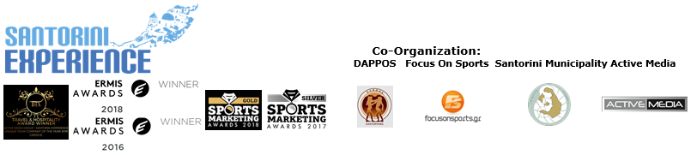
PRESS RELEASE

Travel in comfort to the 5th Santorini Experience

50% discount on all ferry routes from the Aegean islands

Athens, July 16, 2019. Santorini will be found once again at the heart of the global sports map, in October, through the organization of “Santorini Experience”. Amateur and professional athletes will discover the athletic side of the island for the 5th year, from October 4-6, 2019, through running races, admiring the Cycladic architecture overlooking the Caldera and through a swimming race in the deep blue sea with the necessary volcanic energy.

“Santorini Experience” ensures every year the best service for all participants, creating ideal conditions for all travelers. All those traveling to the island by ferry for the 5th “Santorini Experience”, will be able to enjoy once again this year the safety and comfort of Blue Star Ferries. The top Greek shipping company offers 50% discount on the ferry tickets, from/to Santorini and 30% discount on vehicles to all those visiting the event and the island from October 1st to 10th 2019. Each person who has completed his/her registration is entitled to the same discount for 3 more people (if these are his/her escorts) or for 4 people (if these are family members).
Participants who wish to book their tickets, must complete their registration and timely contact the following port offices, at least 3 work days before departure: Piraeus: GELASAKIS SHIPPING & TRAVEL, tel. +30 210 4222440, Santorini: DAKOUTROS TRAVEL, tel. 22860 22201, Paros: ERKYNA TRAVEL, tel. +30 22840 23112, Syros: VASSILIKOS PREMIUM SERVICES, tel. +30 22810 844444, Naxos: ZAS TRAVEL, tel. +30 22850 23330.
For bookings on the day of ferry’s departure, the discount offer will not be applicable.

At the same time, Avance gives the opportunity to participants in the 5th “Santorini Experience” to make their reservation, for any vehicle of their choice regarding their travel to the island during the period of the event (pick up service from the airport or port), with a 15% discount on the official price list. In terms of bookings, participants may send an email to sales(at)avance.gr.

On Friday, October 4, 2019, the awarded Santo Maris Oia Luxury Suites & Spa as the official sponsor of “Santorini Experience” will give the opportunity to people to admire the enchanting view of the famous sunset in Oia, by hosting a Sunset Pilates Session with the exceptional instructor, Mandy Persaki. Limited seats will be available for the session. Interested parties can call: +30 28975 02151.
Hospitality sponsors are the keystone to the prominence and development of sports tourism in Santorini and one of the most important factors for the success of “Santorini Experience”. Until now, this year’s effort is supported with special offers and prices by: Santorini Hoteliers Association, Meltemi Hotels & Resorts, Athina Luxury Suites, Santo Maris Oia Luxury Suites & Spa, Canaves Oia, West East Suites, Andronis Arcadia, Vedema a Luxury Collection Resort, Mystique a Luxury Collection Hotel, Santo Houses, Desiterra Luxury Suites & Villas, 270 Oia’s View, Fanouris Condo, Monolithia, Casa Iphigenia, Sienna Resort, Esperas Santorini, Loizos Stylish Residencies, Iokasti Villa, Olive Cave Houses and Mesana Stone Houses, while participation continues.
Travel to Santorini, under the ideal weather conditions from October 4-6, and take advantage of the accommodation offers from hospitality sponsors and partners of the event like VitaNTravel which offers accommodation packages starting from 130€ per person for three days, including accommodation and ferry tickets. For more information visit: http://vitantravel.gr/

Santorini is an island in which use of means of transportation is necessary and DNA Travel provides its services for this purpose. Participants will be able to take advantage of the special offer created by DNA Travel for the days of Santorini Experience and arrange a transfer from/to their hotels and from/to the airport or the port they arrive at a cost of €30.00 for up to 4 people and with €5.00 extra cost for every extra person. Reservations can be made at info(at)dnatravel.gr and info(at)dnatravelgreece.com, but also at the following telephone numbers: +306972245343, +306980027609, +302286021179.

2019 Santorini Experience offers
Take advantage of the offers available on ferry tickets, car rentals and accommodation for “Santorini Experience” at the following link:
http://www.santorini-experience.com/en/event-info/offers.html

“Santorini Experience” as an event has many difficulties, but the pleasure and experience someone gains from his participation are even more. Enjoy some backstage moments at the following video: https://youtu.be/N3ai8qEDXQg

Registrations for swimming and running continue
From 1/6/2019, participants may register in the event according to the final wave of registrations which lasts until the start of the event. Register now on the following link: https://activemedia.travelotopos.com

Attend Real Madrid’s camp in Santorini!
In the framework of “Santorini Experience”, and in cooperation with MGC Soccer Central, head coaches from the academies of Real Madrid will visit Santorini for the first time and specifically the facilities of the athletic center Playland, from October 3-6, 2019 and teach football to children aged between 6 and 16, using the coaching methodologies of Los Merengues! Register now. For more information visit: http://www.frmclinicsgreece.com

Samsung is the event’s official technology partner for one more year.
Official sponsors of the event include Ford Motor Hellas, Athina Luxury Suites, Santo Maris Oia Luxury Suites & Spa, “Vikos” Natural Mineral Water, Blue Star Ferries and Alafouzos Sport.
For another year, Luanvi is the event’s official sports supplier.
Official supporters of the event are: Santorini Hoteliers Association, Meltemi Hotels & Resorts and Boatmen Union Santorini.
Avance Rent A Car is the official rental partner.
National Geographic is the strategic partner of the event and 24 Media its premium media partner.
DNA Travel is the official transport partner.
“Santorini Experience” is assisted by West East Suites, Lifeguard Patrol, Voluntary Lifeguards of Santorini, Mediterranean Dive Club, Atlantis Dive Center and Santorini Nautical Club.

“Santorini Experience” has joined the Greek actions of the #BeactiveHellas 2019 program of the European Commission and is under the auspices of the General Secretariat of Sports.
“Santorini Experience” is a co-organization of Municipality of Santorini, Municipal Sports Cultural Environmental Organization of Santorini (DAPPOS) and Active Media Group.
The event is held under the auspices of the Greek National Tourism Organization with the approval of the Hellenic Swimming Federation.
More info at: www.santorini-experience.com

Official Hashtag: #SantoriniExperience

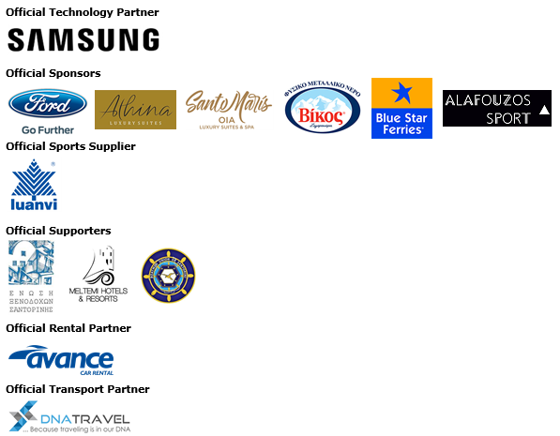

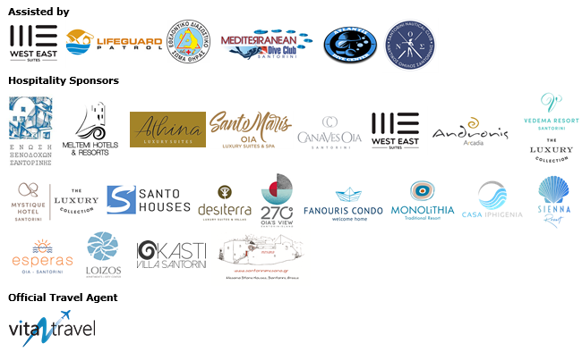



Member of:




Under the Auspices of the Greek National Tourism Organization


Approved by the Hellenic Swimming Federation
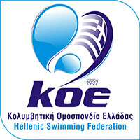

---


Information for the editors:

Press Office Contact:
Tel.: +30 210 9343020, fax: +30 210 9316505
e-mail: pr@activemedia.com.gr

Website: www.santorini-experience.com
Facebook Page: https://www.facebook.com/SantoriniExperience
Instagram Page: https://www.instagram.com/santoriniexperience/
Twitter Account: https://twitter.com/Sant_Experience
YouTube Channel: https://www.youtube.com/channel/UCGconq7q45TYim8qFg71XlA

