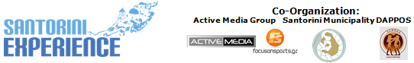
Under the Auspices of the Greek National Tourism Organization
& the Hellenic Swimming Federation

PRESS RELEASE
Athens, 12 October 2016

October, the month of swimming, of running, of Santorini!

Participations from Europe, Asia, Africa, Oceania, North & South America and
international promotion around the whole world through FOX Sports!

The curtain for the special sports tourism event “Santorini Experience 2016” fell in the best possible way, giving away unprecedented times and creating great memories for each participant and every visitor who found himself in the magical volcanic island on 7-9 October 2016!

“Santorini Experience”, at its 2nd consecutive year of materialization exceeded all expectations in the number of participations and the occupancy of hotels in the island by attracting the global interest of athletes, participants and visitors! In particular, 3 Olympic Champions, 2 World Champions, 1 European Champion, 1 Greek Champion and hundreds of professional and amateur athletes of all ages (75 years old was the oldest athlete) took part in the activities of the sports weekend while thousands of visitors swarmed the island to attend this unique event!
The global nature of the event was reflected in the entries recorded from 28 countries and more particularly from USA, Canada, Colombia, Chile, New Zealand, England, France, Germany, Ireland, Italy, Spain, Russia, Netherlands, Finland, Sweden, Switzerland, Romania, Scotland, Slovakia, Ukraine, South Africa, Morocco, Tahiti, Taiwan, Turkey, Albania, Cyprus and of course Greece.
Actually many of the participants didn’t hesitate to even travel 8,286 miles (South Africa) and 11,000 miles (New Zealand) in order to swim in the magical Caldera.

The extroversion of sports tourism was the first and basic target of this year’s event. “Santorini Experience” will have an outstanding international promotion, as FOX Sports of FOX Networks Group, as the Official Broadcaster of “Santorini Experience” will display the event’s sports documentary, to millions of homes in Europe, Asia and Africa, creating a unique television product.

Athletes and visitors of the event flew with the official airline partner of “Santorini Experience” Ryanair, which in response to the huge demand for the sport event, embraced it by adding 5 additional flights (beyond its 2 daily scheduled) in the Athens-Santorini route, carrying out a total of 25 flights in 10 days, with an occupancy reaching 100%, contributing to the overall promotion of the destination.
For the ferry access to the island, Blue Star Ferries took care of the immediate and safe service of participants, the convenience of attendants and “Santorini Experience” spectators by offering 50% discount on ferry tickets to everyone who visited the island, recording a significant increase in its bookings, within the days of the event.

“Santorini Experience 2016” schedule was even richer this year compared to the first year, having for the first time the kind support and auspices of the Greek National Tourism Organization.
More than 1.400 children participated in all children's activities of the event. Specifically on Wednesday, 5th and Thursday, October 6th, 2016, the activity of Kids’ Athletics was presented for the first time in Thira Stadium (Panthiraikos) at Fira by the Olympic and World Champion in 400m. hurdles Periklis Iakovakis. The activity aimed at getting children acquainted with the track and field sports, as it has been developed and established by a special panel of scientists from IAAF (International Association of Athletics Federation) and is officially implemented in Greece by the Hellenic Athletics Federation (SEGAS) in cooperation with the Ministry of Education.
On Friday, October 7, 2016, students ran the 1km running route that was held at the Indoor Hall of DAPPOS, at Fira.
Respectively at noon, the twice Silver Olympic Medalist, Alexandros Nikolaidis undertook to introduce the secrets of TaeKwonDo martial art to beginners and advanced athletes, at the Indoor Hall of DAPPOS, at Fira.
On Friday, a Meet & Greet was held with the great Silver Olympic Medalists Spyros Gianniotis and Alexandros Nikolaidis and top athletes such as the World Champions Kelly Araouzou and Antonis Fokaidis, the European Champion Giorgos Arniakos and the Greek Champion Dimitris Negris, at Alafouzos Sport store (official sponsor of the event) at Fira that supported for the second consecutive year the organization and helped its implementation from the beginning.

On Saturday October 8th 2016, catching the limit of 500 participants (under the safety limit of the paths set by the former marathon runner, holder of national best performance on the classical route, running coach and director of All About Running, Nikos Polias who designed and edited the routes) runners of all abilities had the opportunity to run at the exceptional routes of 5km (running and dynamic walking), 10 km and 15 km (total positive altitude: 834 m.) overlooking the unique images of the volcano, the Caldera and the sites Imerovigli, Firostefani and Oia. All routes had as start and finish point the desalination plant in Oia.

On Saturday night, Municipality of Santorini and the Municipal Sports Cultural Environmental Organization of Santorini (D.A.P.P.O.S.) honored at a glittering event held at the conference center Petros M. Nomikos in Fira, the silver Olympic medalist and World Champion in open water swimming Spyros Gianniotis, the Federal Technical Coach of Swimming, Nikos Gemelos, the World Champion in open water swimming, Kelly Araouzou, the President of the Hellenic Swimming Federation, Mr. Dimitrios Diathesopoulos and the twice silver Olympic medalist in TaeKwonDo, Alexandros Nikolaidis.

On Sunday, October 9, 2016 participants of the sport of swimming (with the presence of the elite of the Greek national open water swimming team) had the opportunity to swim in the unique swimming route of 1.5 mile (2.4 km) of “Santorini Experience”, from the volcano to the old port in Fira.
The route was designed by the Federal Technical Coach of Swimming, with Olympic and World distinctions in open water swimming and Technical Director of the event in swimming, Nikos Gemelos. The event was held under the auspices of the Hellenic Swimming Federation (KOE), something that happened for the first time in open water swimming, at a sports tourism event, marking the explosive participation achieved from swimmers and swimming clubs from all over Greece and abroad.
The swimming day was supported and respectively implemented with the safety of Santorini Boatmen Union, Santorini Yachting Club, National Lifeguards of Santorini, Aegean Divers and the Lifeguard Schools from Athens, Piraeus (European Lifeguard School) and Katerini (Lifeguard Patrol). More than 25 vessels and more than 70 people in the water helped in the smooth running and safety of the race.

For the second consecutive year, athletes and organizers moved with the safety and efficient engines of the cars of Ford Motor Hellas, the official supporter of “Santorini Experience”. The athletes who took part in the event had also the opportunity to quench their thirst with the Natural Mineral Water “Vikos” that contributes to the good functioning of the body during sports.

“Santorini Experience” stood alongside “Iron Samba”!
Part of the “Santorini Experience” revenues will be given to the Give & Fund created to support Maria Sampanidou or “Iron Samba” rehabilitation race who gives the most crucial fight of her life. Anyone can support Maria Sampanidou through the following page: http://www.giveandfund.com/giveandfund/project/Ironsamba

The event received very significant support by Avance Rent A Car, which covered with its fleet and its exemplary service, the event’s and all visitors’ needs in car rentals.
Accordingly, Saucony company offered beautiful gifts to participants who finished in the top positions in running and swimming.
The event was also supported by Aqua Vista Hotels, Santorini Hoteliers Association, Meltemi Hotels & Resorts, Aegean Plaza Hotel, Arena, Village Cinemas, Demilmar Restaurant Beach Bar and Passagio Santorini Oia.

“Santorini Experience” could not have been successfully completed without the valuable support of nineteen hospitality sponsors that hosted the people of the event and offered special prices and discounts on their accommodation, raising the total occupancy of accommodation in all parts of the island, the days of the event. Specifically these are: Aqua Vista Hotels, Santorini Hoteliers Association, Meltemi Hotels & Resorts, Aegean Plaza Hotel, Athina Luxury Suites, Santorini Secret Suites & Spa, Vedema A Luxury Collection Resort Santorini, Sunday Suites Santorini, Caldera Collection, West East Suites, 270 Oia's View, White Pearl Villas, Suites of the Gods Spa Hotel Santorini, Central Fira Hotel, Memories Hotel, Loizos Stylish Residencies, Esperas Santorini, Maistros Village Hotel, Sienna Residencies

After the end of “Santorini Experience 2016” Santorini Mayor, Mr. Anastasios Nikolaos Zorzos said: “Santorini Experience has already become a tradition for our island and both locals and visitors embraced with great fervor. The volcanic soil and the energy that our place transmits in conjunction with the sports activity, guarantee a unique life experience. Santorini island offers alternative forms of tourism throughout the year and Santorini Experience proves it. We continue this effort; we support and participate actively so that our island remains in the first preference positions of the visitors. Many thanks to all organizers, sponsors and our volunteers; without them we would not realize this successful event”.

Respectively the President of D.A.P.P.O.S., Mr. Eleftherios Tzouros noted: “The beautiful, magical, unique and endless journey of Santorini Experience continued in 2016 even more dynamically and reminded us that the original idea to borrow the caldera of Santorini so that the participants will test their limits was and remains unique. Santorini Experience 2016 opened the sails and already showed us from its second year its dynamics fully satisfying the objectives we set in the beginning. The joy, the smile and satisfaction on the face of the participants is the energy that we got so that this sports journey will never end. Activities such as the kids’ athletics, the students running and the TaeKwonDo training of students highly demonstrated how interested we are in the sports education and the progress of children of Santorini. I would like to also say a big thank you to all our sponsors and volunteers”.

The event had the honor of the presence of the Greek National Tourism Organization General Secretary, Mr. Dimitrios Tryfonopoulos and the President of the Hellenic Swimming Federation, Mr. Dimitrios Diathesopoulos.

The event was assisted by Diana “exoplizein”, Kassimatis Cycling, Science In Sport, Hellenic Athletics Federation (SEGAS), IAAF Kids Athletics, Grafistes, Aeromotion Aerial Video Photography, Rivios Thanos Photography, Aegean Divers, National Lifeguards of Santorini, University of Peloponnese – Department of Sports Management Implementation and Lifeguard Patrol.

“Santorini Experience” in cooperation with the MPASS innovated by presenting the Santorini Experience chatbot!
The event served, directly and reliably via Facebook Messenger, all the participants of the event who needed to have all the necessary information for the top sports tourism event!
Through “Santorini Experience” Chatbot, participants, when writing their bib number in running were able to receive a message with their time, at the time of their finishing, and were informed on offers that were active during the event, and on individual activities which took place.

“Santorini Experience” was held with the collaboration between the Municipality of Santorini, the Municipal Sports Cultural Environmental Organization of Santorini (D.A.P.P.O.S.) and Active Media Group.

Official Broadcaster: FOX Sports
Official Sponsors: Alafouzos Sport, Blue Star Ferries, With the Kind Support of the Greek National Tourism Organization, Santorini Boatmen Union
Official Airline Partner: Ryanair
Official Supporters: Ford Motor Hellas, “Vikos” Natural Mineral Water, Avance Rent A Car, Aqua Vista Hotels, Santorini Hoteliers Association, Meltemi Hotels & Resorts, Aegean Plaza Hotel, Saucony, Arena, Village Cinemas, Santorini Yachting Club, Demilmar Restaurant Beach Bar, Passagio Santorini Oia
Hospitality Sponsors: Aqua Vista Hotels, Santorini Hoteliers Association, Meltemi Hotels & Resorts, Aegean Plaza Hotel, Athina Luxury Suites, Santorini Secret Suites & Spa, Vedema A Luxury Collection Resort Santorini, Sunday Suites Santorini, Caldera Collection, West East Suites, 270 Oia's View, White Pearl Villas, Suites of the Gods Spa Hotel Santorini, Central Fira Hotel, Memories Hotel, Loizos Stylish Residencies, Esperas Santorini, Maistros Village Hotel, Sienna Residencies
Assisted by: Diana “exoplizein”, Kassimatis Cycling, Science In Sport, Hellenic Athletics Federation (SEGAS), IAAF Kids Athletics, Grafistes, Aeromotion Aerial Video Photography, Rivios Thanos Photography, Aegean Divers, National Lifeguards of Santorini, University of Peloponnese – Department of Sports Management Implementation, Lifeguard Patrol, European Lifeguard School
With the Kind Support & Under the Auspices of the Greek National Tourism Organization
Under the Auspices of the Hellenic Swimming Federation
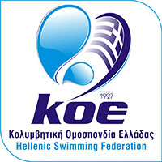

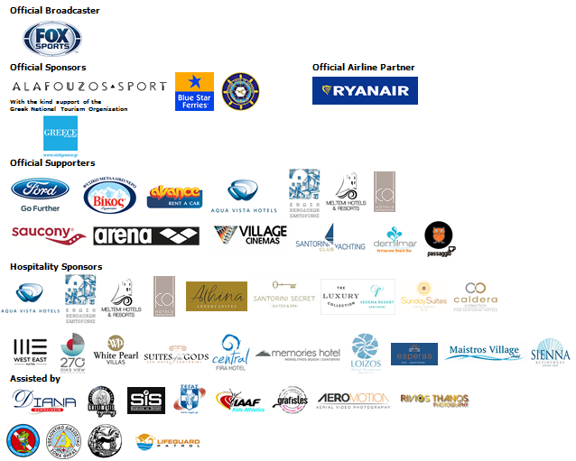
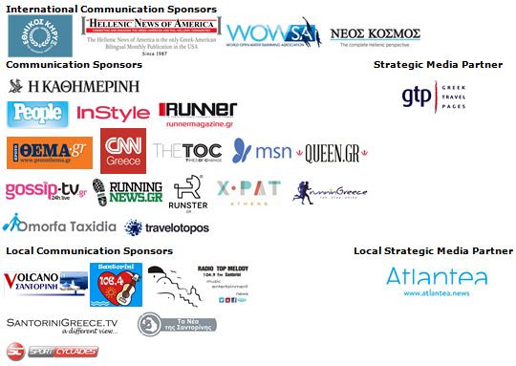

Website: www.santorini-experience.com
Facebook Page: https://www.facebook.com/SantoriniExperience
Facebook Event: https://www.facebook.com/events/969713156476789/
Twitter Account: https://twitter.com/Sant_Experience
YouTube Channel: https://www.youtube.com/channel/UCGconq7q45TYim8qFg71XlA
Instagram Page: https://www.instagram.com/santoriniexperience/
Google+ Page: https://plus.google.com/u/0/b/110202716050196467073/110202716050196467073
Hashtag: #SantoriniExperience

