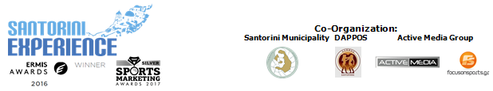

Under the Auspices of the Greek National Tourism Organization
& the Hellenic Swimming Federation

PRESS RELEASE

Record of participations in the 3rd “Santorini Experience”

With 40 countries and smashing presence in running and swimming

Athens, October 10 2017. “Santorini Experience” was completed with absolute success for a 3rd consecutive year, on the enchanting island of the Cyclades. The top sports tourism event in Greece, with a TV broadcast in 87 countries through the FOX Sports TV network, was completed with a record of participations in the running and swimming races with more than 1500 participations.

Popular abroad!
“Santorini Experience” is officially the event of the Hellenic Swimming Federation (having the auspices for the second year in a row) with the most popularity abroad, for amateur and professional athletes in Greece, while in running follows the events organized by the Hellenic Athletics Federation (SEGAS) such as the Athens Marathon.
At the same time, foreign participations surpassed every precedent, as athletes from around 40 countries were "hosted" in Santorini. Indicatively, the attendance was extremely high from Australia, UK, Germany, France, USA, Canada, China, Russia, New Zealand, South Africa, Singapore and Hong Kong.

An international ambassador by the side of the established and promising Greek swimmers!
The Hungarian swimmer Attila Manyoki, the recognized athlete in open water swimming with several successes and a member of the International Marathon Swimming Hall of Fame (IMSHOF), took part for the first time in the event. The presence of swimmers was dynamic with top professional athletes such as the Greek open water champion Kelly Araouzou and members of the Greek national team, Antonis Fokaidis, Giorgos Arniakos and Dimitris Negris. In addition, for the first time in an open water swimming race, more than 10 Greek champions took part.
In Santorini, we enjoyed the new young Greek leading open water swimmers who follow the steps of Spyros Gianniotis (he swam in Santorini in 2015 and 2016 before his withdrawal) under the instructions of the federal coach Nikos Gemelos.
The technical director of the swimming race not only applied the new 1.1 mile open water swimming route (from Skaros to the old port of Fira) on Sunday morning, due to the difficult weather conditions, but also supervised its conduct so that everything would be done in accordance with the regulations of FINA and the Hellenic Swimming Federation. Swimmers started in groups and not all together, following all safety rules.
Of course, there were 50 specialized escorts in the water who contributed, with the assistance of Lifeguard Patrol, which also had several lifeguard boats, the people from Santorini who helped with their own boats, the Voluntary Lifeguards of Santorini, Atlantis Dive Center and above all Santorini Boatmen Union that transferred and protected the organization of the open water swimming.
The traditional sweet of Santorini, melitinia (offered by Manos Pastry Shop) as well as seasonal fruits were offered to the swimmers after the end of their race.

Best innovative sports tourism event!
For the first time in a sports event in Greece, Samsung as the official technology partner was present with its innovative services through the Samsung Galaxy ecosystem. The Samsung Galaxy S8 and S8+, combined with the Gear 360 camera and Gear VR, enrich the experience of those attending and watching the event with unique content at 360 degrees.
You may find some relevant photos in the following link: https://www.dropbox.com/sh/t1v044zbd1bewqx/AAAkq3B1HLcCnEaX-mfI3F8Ma?dl=0

The award-winning event did not stop its innovation here. The GoPro 6 action camera was first used in Greece, with its simultaneous arrival at a world premiere. The GoPro HERO6 Black, with its breathtaking analysis and waterproof design, has especially helped in having the best and most impressive shots in the swimming and running activities. Relevant photos are available in the following link: https://www.dropbox.com/sh/2hmgdqube2vihjl/AABWEbS-LNujBm3aA7P42dETa?dl=0

A difficult and demanding route!
Hundreds of athletes were present in the running routes. The runners participated in the 5km “Aristides Alafouzos”, 10 km and 15 km running routes, having as a “background” the unique images of the volcano overlooking the Caldera and passing through the settlements of Imerovigli, Firostefani and Oia. The 5km route took this year's name “Aristides Alafouzos” in memory of the great benefactor of the island. Indeed, the nephew of the late Alafouzos, Mr. Giannis Haidemenos, said after the starting signal he gave together with the Mayor of Santorini, Nikos Zorzos, on the 5km route: “I am very pleased because the effort made by Aristides Alafouzos is justified, being a sponsor in the whole island of Santorini all these years. It is a great honor for us and very important that this race takes place in his memory”.
In the following link you may find the results in running and open water swimming races: http://www.santorini-experience.com/event-info/results2017.html

Sports for all!
Excitement was spread to the young children at the 1km running race held on Friday, October 6th, with the support of Vikos, at Panthiraikos Stadium in Fira, with the presence of the Olympic and World Champion at 400m. with hurdles Periklis Iakovakis (who ran also the 5km) and Greek-American ultramarathon Dean Karnazes, who participated in the 5km and 15 km running races, while he signed his last book at Alafouzos Sport store (sponsor of the event) in Fira. TaeKwonDo lessons were conducted to advanced and amateur athletes by the twice silver Olympic medalist Alexandros Nikolaidis, while the warm-up of the athletes in running was undertaken by the pilates instructor Mandy Perskaki.

Easy access and promotion!
Participating athletes traveled to “Santorini Experience”, with the official airline partner of the event, Ryanair that offered the possibility of connecting Athens with Santorini with direct flights from 13 cities abroad. The leading Greek shipping company Blue Star Ferries, as a sponsor of the event, facilitated the ferry transfer by offering a 50% discount on the ferry tickets and vehicles of the participants, assisting the travel of Greek and foreign athletes.
The foreign participants and visitors approached the event mostly in groups this year, showing the results of the promotion which was made through the tourism expo in Sweden, the campaign implemented in Germany targeted at the first autumn school holidays and the targeted communication strategy in China, Australia, New Zealand, South Africa and America was effective.

Local Government Co-operation and Private Initiative
All these wouldn’t have been accomplished without the full cooperation of the Municipality of Santorini, DAPPOS and Active Media Group, as well as the supporters of the event.
For the third consecutive year, ambassadors and organizers moved with the safety and efficient engines of the cars of Ford Motor Hellas, the official supporter of “Santorini Experience”. Throughout the three-day event organizers and athletes drove with the excellent fuel quality of EKO! At the same time, “Vikos” offered to the athletes who took part the opportunity to quench their thirst with the Natural Mineral Water “Vikos”. Official supporters also included Avance, Santorini Hoteliers Association, Aqua Vista Hotels, Santo Maris Oia Luxury Suites & Spa (that welcomed the guests on Friday and organized the Sunset Cocktail under the music of the great Cretan lyre player, songwriter and composer Psarantonis) and Athina Luxury Suites.

The hospitality sponsors that supported the event from Santorini were: Santorini Hoteliers Association, Meltemi Hotels & Resorts, Aqua Vista Hotels, Athina Luxury Suites, Santo Maris Oia Luxury Suites & Spa, Aegean Plaza Hotel, Andronis Concept, Vedema A Luxury Collection Resort Santorini, Canaves Oia, West East Suites, Desiterra Luxury Suites & Villas, 270 Oia's View, Central Fira Hotel, Memories Hotel, Loizos Stylish Residencies, Fanouris Condo, Monolithia Hotel, Esperas Santorini, Sienna Residencies, Hotel Rivari Santorini, White Pearl Villas, Caldera Collection.
In Athens, Wyndham Grand Athens assisted the event as an official supporter and hospitality sponsor.

The event was assisted by Sunset Oia Sailing Cruises, Alios Ilios, Assyrtico Wine Restaurant Café, Lifeguard Patrol, Voluntary Lifeguards of Santorini and Atlantis Dive Center.

“Santorini Experience” took place under the auspices of the Greek National Tourism Organization and the Hellenic Swimming Federation with the co-organization of the Municipality of Santorini, DAPPOS and Active Media Group.

Official Hashtag: #SantoriniExperience

Official Airline Partner: Ryanair
Official Sponsors: Blue Star Ferries, Alafouzos Sport, Athina Luxury Suites
Official Technology Partner: Samsung
Official Supporters: Ford Motor Hellas, Natural Mineral Water “Vikos”, Avance Rent A Car, Aqua Vista Hotels, Santo Maris Oia Luxury Suites & Spa, ΕΚΟ, GoPro, Wyndham Grand Athens, Santorini Boatmen Union
Hospitality Sponsors: Santorini Hoteliers Association, Meltemi Hotels & Resorts, Aqua Vista Hotels, Athina Luxury Suites, Santo Maris Oia Luxury Suites & Spa, Aegean Plaza Hotel, Andronis Concept, Vedema A Luxury Collection Resort Santorini, Canaves Oia, West East Suites, Desiterra Luxury Suites & Villas, 270 Oia's View, Central Fira Hotel, Memories Hotel, Loizos Stylish Residencies, Fanouris Condo, Monolithia Hotel, Esperas Santorini, Sienna Residencies, Hotel Rivari Santorini, White Pearl Villas, Caldera Collection
Assisted by: Sunset Oia Sailing Cruises, Alios Ilios, Assyrtico Wine Restaurant Café, Lifeguard Patrol, Voluntary Lifeguards of Santorini, Atlantis Dive Center
Official Travel Agent: VitaNTravel

Under the Auspices of the Greek National Tourism Organization
Under the Auspices of the Hellenic Swimming Federation
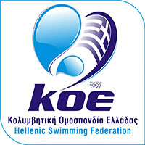

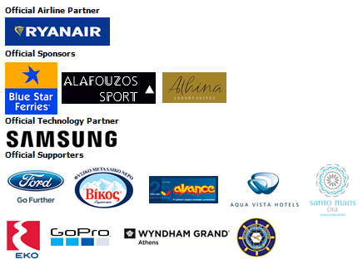
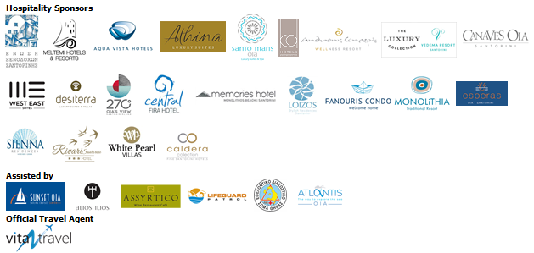



Information for the editors:

Press Office Contact:
Tel.: +30 210 9343020, fax: +30 210 9316505
e-mail: pr@activemedia.com.gr
Website: www.santorini-experience.com
Facebook Page: https://www.facebook.com/SantoriniExperience
Twitter Account: https://twitter.com/Sant_Experience
YouTube Channel: https://www.youtube.com/channel/UCGconq7q45TYim8qFg71XlA
Instagram Page: https://www.instagram.com/santoriniexperience/

